**PRACTICAL NO. 1**

**Aim:** To develop a program for multi-client chat server using Socket.

**Program:**

**ChatServer.java**

//RPC

//ChatServer.java

import java.net.*;

import java.io.*;

public class ChatServer extends Thread

{

ServerSocket ss;

Socket soc;

BufferedReader br,br1;

PrintWriter out;

String str;

public ChatServer()

{

try

{

ss = new ServerSocket(9999);

soc = ss.accept();

br = new BufferedReader(new InputStreamReader(soc.getInputStream()));

// InputStreamReader ir=new InputStreamReader(soc.getInputStream());

// br = new BufferedReader(ir);

System.out.println("Chat Server Started");

start();

new InnerServer();

}

catch (Exception e)

{

e.printStackTrace();

}

} //end of ChatServer()

public void run()

{

try

{

while(true) // the data coming client is displayed

{

str = br.readLine();

System.out.println("Client says : " + str);

}

}

catch (Exception e)

{

e.printStackTrace();

}

} // end of run()

class InnerServer // inside ChatServer class

// the data from server will be read from console and sent to client.

{

String str1;

InnerServer() // constructor

{

try

{

br1= new BufferedReader(new InputStreamReader(System.in));

out = new PrintWriter(soc.getOutputStream(), true);

while (true) // read the data from br1 and put in 'out'

{

//str1 = br1.readLine();

//out.println(str1);

out.println(br1.readLine());

}

}

catch (Exception e)

{ e.printStackTrace(); }

}

} // end of InnerSErver class

public static void main(String args[]) // method of chatServer class

{

new ChatServer();

}

}

**ChatClient.java**

// RPC

//ChatClient.java

import java.net.*;

import java.io.*;

public class ChatClient

{

Socket soc;

BufferedReader br,br1;

PrintWriter out;

String str;

public ChatClient() //constructor

{

try

{

soc = new Socket(InetAddress.getLocalHost(), 9999);

br = new BufferedReader(new InputStreamReader(System.in));

out = new PrintWriter(soc.getOutputStream(), true);

System.out.println("Chat Client Started");

while (true)

{

str = br.readLine();

out.println(str);

new InnerClient();

}

}

catch (Exception e)

{

e.printStackTrace();

}

}

class InnerClient extends Thread // inside Chatclient class

{

String str1;

InnerClient()

{

try

{

br1 = new BufferedReader(new InputStreamReader(soc.getInputStream()));

start();

}

catch (Exception e)

{

e.printStackTrace();

}

}

public void run()

{

try

{

while (true)

{

str1 = br1.readLine();

System.out.println("Server says : " + str1);

}

}

catch (Exception e)

{

e.printStackTrace();

}

}

} // end of InnerClient class

public static void main(String args[]) // method of outer class ChatClient

{

new ChatClient();

}

}

**Output:**

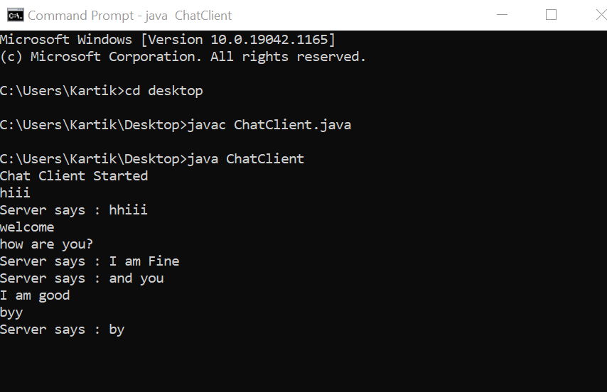

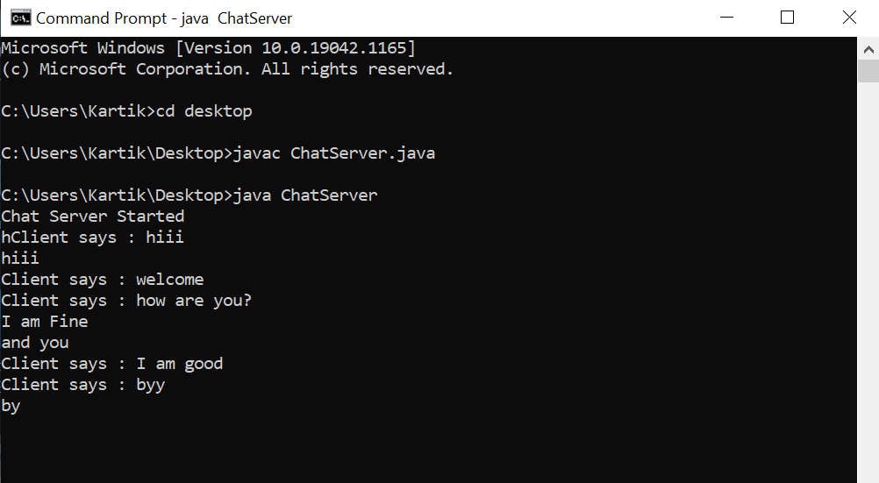

**PRACTICAL NO. 2**

**Aim:** To implement a Server calculator using RPC concept.

**Program:**

**RPCServer.java**

//To Implement a server calculator containing ADD(),MUL(),SUB()

import java.util.*;

import java.net.*;

class RPCServer

{

DatagramSocket ds;

DatagramPacket dp;

String str, methodName, result;

int val1,val2;

RPCServer()

{

try

{

ds=new DatagramSocket(1200);

byte b[]=new byte[4096];

// int a[]=new int[100];

while(true)

{

dp=new DatagramPacket(b,b.length);

ds.receive(dp);

str=new String(dp.getData(),0,dp.getLength()); // add 10 20

if(str.equalsIgnoreCase("q"))

{

System.exit(1);

}

else

{

StringTokenizer st = new StringTokenizer(str," ");

int i=0;

while(st.hasMoreTokens())

{

// String token=st.nextToken();

methodName=st.nextToken(); // add

val1 = Integer.parseInt(st.nextToken()); // 10

val2 = Integer.parseInt(st.nextToken()); // 20

}

}

System.out.println(str); // print add 10 20

InetAddress ia = InetAddress.getLocalHost();

if(methodName.equalsIgnoreCase("add"))

result= "" + add(val1,val2);

else if(methodName.equalsIgnoreCase("sub"))

result= "" + sub(val1,val2);

else if(methodName.equalsIgnoreCase("mul"))

result= "" + mul(val1,val2);

else if(methodName.equalsIgnoreCase("div"))

result= "" + div(val1,val2);

byte b1[]=result.getBytes(); // convert string data into byte

DatagramSocket ds1 = new DatagramSocket();

DatagramPacket dp1 = new DatagramPacket(b1,b1.length,InetAddress.getLocalHost(), 1300);

System.out.println("result : "+result+"\n");

ds1.send(dp1);

}

}

catch (Exception e)

{

e.printStackTrace();

}

}

public int add(int val1, int val2) { return val1+val2; }

public int sub(int val3, int val4) { return val3-val4; }

public int mul(int val3, int val4) { return val3*val4; }

public int div(int val3, int val4) { return val3/val4; }

public static void main(String[] args){ new RPCServer(); }

}

**RPCClient.java**

import java.io.*;

import java.net.*;

class RPCClient

{

RPCClient()

{

try

{

InetAddress ia = InetAddress.getLocalHost();

DatagramSocket ds = new DatagramSocket();

DatagramSocket ds1 = new DatagramSocket(1300);

System.out.println("\nRPC Client\n");

System.out.println("Enter method name and parameter like add 10 20\n");

System.out.println("Press \'q\' to quit \n");

while (true)

{

BufferedReader br = new BufferedReader(new InputStreamReader(System.in));

String str = br.readLine();

byte b[] = str.getBytes();

DatagramPacket dp = new DatagramPacket(b,b.length,ia,1200);

ds.send(dp);

dp = new DatagramPacket(b,b.length);

ds1.receive(dp);

String s = new String(dp.getData(),0,dp.getLength());

System.out.println("\nResult = " + s + "\n");

}

}

catch (Exception e)

{

e.printStackTrace();

}

}

public static void main(String[] args)

{

new RPCClient();

}

}

**Output:**

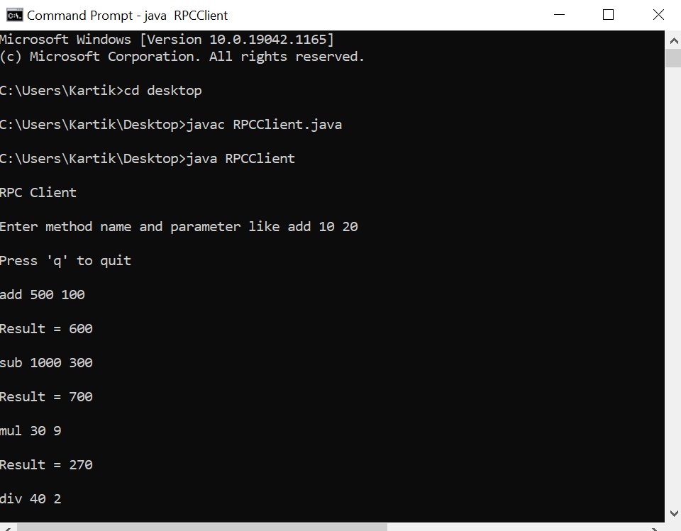

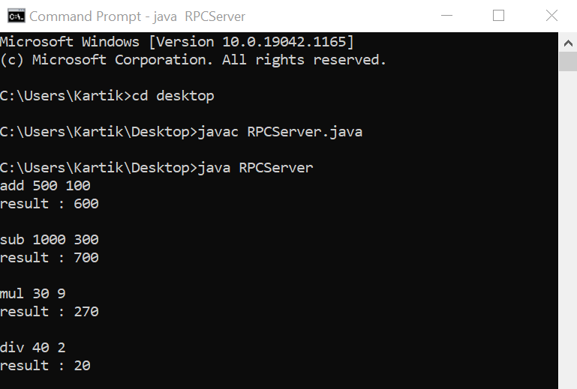

**PRACTICAL NO. 3**

**Aim:** To implement a Date Time Server using RPC concept.

**Program:**

**RPCServer1.java**

//To Implement a Date time server containing date() and time() procedure.

import java.util.*;

import java.net.*;

import java.text.SimpleDateFormat;

class RPCServer1

{

DatagramSocket ds;

DatagramPacket dp;

String str, methodName, result;

int val1,val2;

RPCServer1()

{

try

{

ds=new DatagramSocket(1200);

byte b[]=new byte[4096];

while(true)

{

dp=new DatagramPacket(b,b.length);

ds.receive(dp);

str=new String(dp.getData(),0,dp.getLength());

if(str.equalsIgnoreCase("q"))

{

System.exit(1);

}

else

{

StringTokenizer st = new StringTokenizer(str," ");

int i=0;

while(st.hasMoreTokens())

{

methodName=st.nextToken();

}

}

Calendar c = Calendar.getInstance();

SimpleDateFormat dateFormat = new SimpleDateFormat("dd/MM/yyyy");

Date d = c.getTime();

InetAddress ia = InetAddress.getLocalHost();

if(methodName.equalsIgnoreCase("date"))

result=""+ dateFormat.format(d);

else if(methodName.equalsIgnoreCase("time"))

result= "" + d.getHours() +" : " +d.getMinutes() + " : " +d.getSeconds();

byte b1[]=result.getBytes();

DatagramSocket ds1 = new DatagramSocket();

DatagramPacket dp1 = new DatagramPacket(b1,b1.length,InetAddress.getLocalHost(), 1300);

System.out.println("result : "+result+"\n");

ds1.send(dp1);

}

}

catch (Exception e)

{

e.printStackTrace();

}

}

public static void main(String[] args)

{

new RPCServer1();

}

}

**RPCClient1.java**

import java.io.*;

import java.net.*;

class RPCClient1

{

RPCClient1()

{

try

{

InetAddress ia = InetAddress.getLocalHost();

DatagramSocket ds = new DatagramSocket();

byte b1[]=new byte[50];

DatagramSocket ds1 = new DatagramSocket(1300);

System.out.println("\nRPC Client\n");

while (true)

{

BufferedReader br = new BufferedReader(new InputStreamReader(System.in));

String str = br.readLine();

byte b[] = str.getBytes();

DatagramPacket dp = new DatagramPacket(b,b.length,ia,1200);

ds.send(dp);

if(str.equalsIgnoreCase("q"))

{

System.out.println("server exited...");

System.exit(1);

}

dp = new DatagramPacket(b1,b1.length);

ds1.receive(dp);

String s = new String(dp.getData(),0,dp.getLength());

System.out.println("\n Result = " + s);

}

}

catch (Exception e)

{

e.printStackTrace();

}

}

public static void main(String[] args)

{

new RPCClient1();

}

}

**Output:**

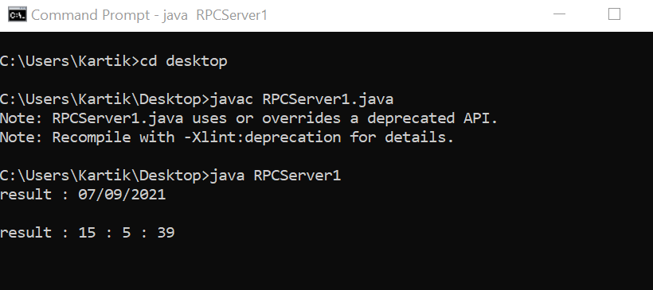

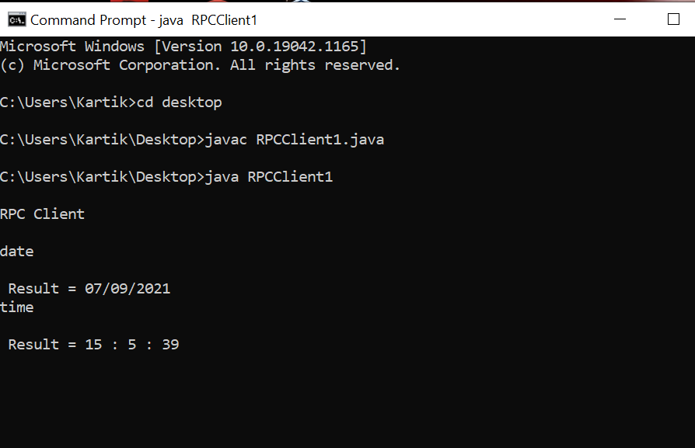

**PRACTICAL NO. 4**

**Aim:** To retrieve day, time and date function from server to client. This program should display server day, time and date. (Use Concept of JDBC and RMI for accessing multiple data access objects).

**Program:**

**DateImpl.java**

// DateImpl.java

import java.rmi.*;

import java.rmi.server.*;

import java.util.*;

public class DateImpl extends UnicastRemoteObject implements IDate

{

public DateImpl() throws RemoteException

{}

public String getDate()

{

Date d=new Date();

return(d.toString());

}

}

**IDate.java**

// IDate.java

import java.rmi.*;

public interface IDate extends Remote

{

String getDate() throws RemoteException;

}

**DateServer.java**

// DateServer.java

import java.rmi.*;

public class DateServer

{

public static void main(String[] args)

{

try

{

DateImpl di=new DateImpl();

Naming.rebind("DServer",di);

System.out.println("Date Server is Ready");

}

catch(Exception e)

{

e.printStackTrace();

}

}

}

**DateClient.java**

// DateClient.java

import java.rmi.*;

public class DateClient

{

public static void main(String[] args)

{

try

{

String url="rmi://127.0.0.1/DServer";

IDate intf=(IDate)Naming.lookup(url);

// IDate intf=(IDate)Naming.lookup("rmi://127.0.0.1/DateServer");

System.out.println("The Date On Server is: "+intf.getDate());

}

catch(Exception e)

{

e.printStackTrace();

}

}

}

**Output:**

**Start rmiregistary in your pc**

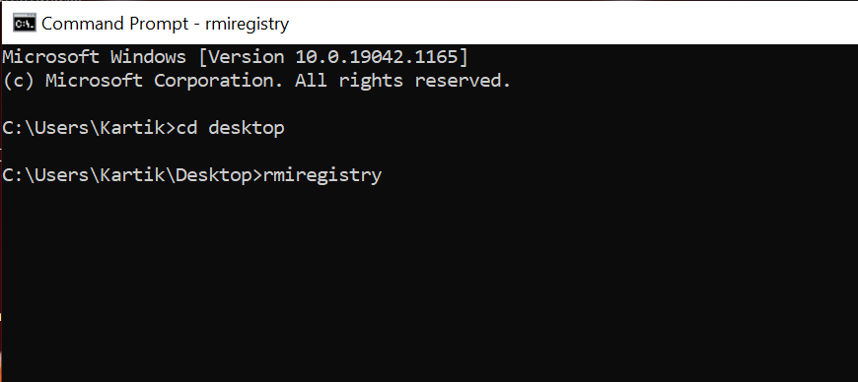

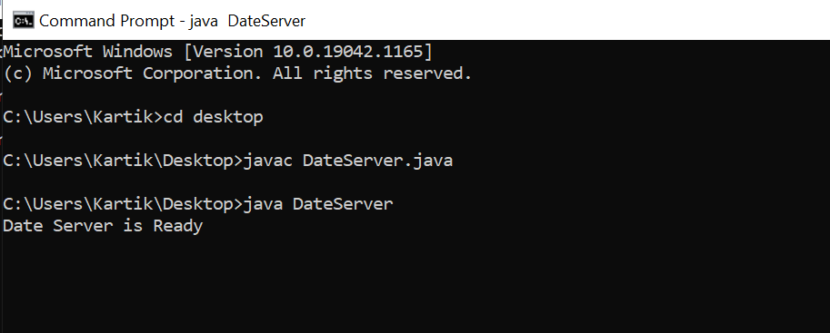

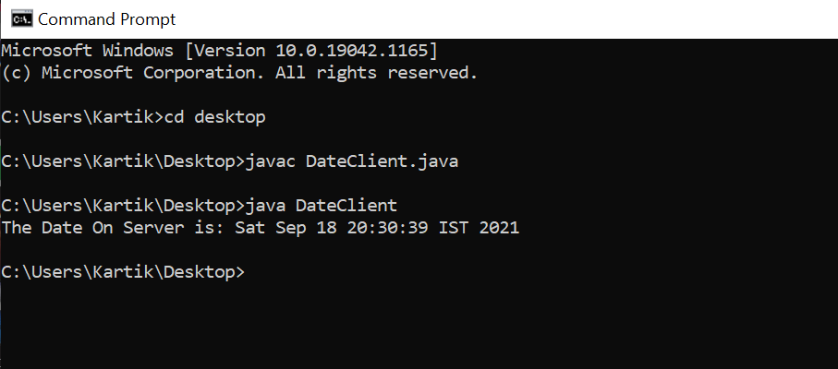

**PRACTICAL NO. 5**

**Aim:** The client should provide an equation to the server through an interface. The server will solve the expression given by the client.

**Program:**

**ImplEqSolve.java**

// implEqSolve.java

import java.rmi.*;

import java.rmi.server.*;

public class implEqSolve extends UnicastRemoteObject implements intfEqSolve

{

public implEqSolve() throws RemoteException

{ }

public int solveEq1(int a,int b) throws RemoteException

{

int ans=(a*a)-(2*a*b)+(b*b);

return ans;

}

public int solveEq2(int a,int b) throws RemoteException

{

int ans=(a*a)+(2*a*b)+(b*b);

return ans;

}

public int solveEq3(int a,int b) throws RemoteException

{

int ans=(a*a*a)-(3*a*a*b)+(3*a*b*b)-(b*b*b); return ans;

}

public int solveEq4(int a,int b) throws RemoteException

{

int ans=(a*a*a)+(3*a*a*b)+(3*a*b*b)+(b*b*b);

return ans;

}

}

**intfEqSolve.java**

// intfEqSolve.java

import java.rmi.*;

public interface intfEqSolve extends Remote

{

public int solveEq1(int a,int b)throws RemoteException;

public int solveEq2(int a,int b)throws RemoteException;

public int solveEq3(int a,int b)throws RemoteException;

public int solveEq4(int a,int b)throws RemoteException;

}

**serverEqSolve.java**

// serverEqSolve.java

import java.io.*;

import java.net.*;

import java.rmi.*;

public class serverEqSolve

{

public static void main(String[]args)

{

try

{

implEqSolve obj=new implEqSolve();

Naming.rebind("hello",obj);

}

catch(Exception e)

{

System.out.println(e);

}

}

}

**clientEqSolve.java**

// clientEqSolve.java

import java.io.*;

import java.net.*;

import java.rmi.*;

public class clientEqSolve

{

public static void main(String[]args)

{

try

{

int num1,num2,res=0,choice;

intfEqSolve object=(intfEqSolve)Naming.lookup("hello");

BufferedReader br=new BufferedReader(new InputStreamReader(System.in));

System.out.println("Equations:-");

System.out.println("1.(a-b)2");

System.out.println("2.(a+b)2");

System.out.println("3.(a-b)3");

System.out.println("4.(a+b)3");

System.out.println("Choose the equation:");

choice=Integer.parseInt(br.readLine());

System.out.println("Enter the value of a and b");

num1=Integer.parseInt(br.readLine());

num2=Integer.parseInt(br.readLine());

switch(choice)

{

case 1:

res=object.solveEq1(num1,num2);

break;

case 2:

res=object.solveEq2(num1,num2);

break;

case 3:

res=object.solveEq3(num1,num2);

break;

case 4:

res=object.solveEq4(num1,num2);

break;

default:

System.out.println("Invalid option");

break;

}

System.out.println("the answer is"+res);

}

catch(Exception e)

{

System.out.println("Exception:"+e);

}

}

}

**Output:**

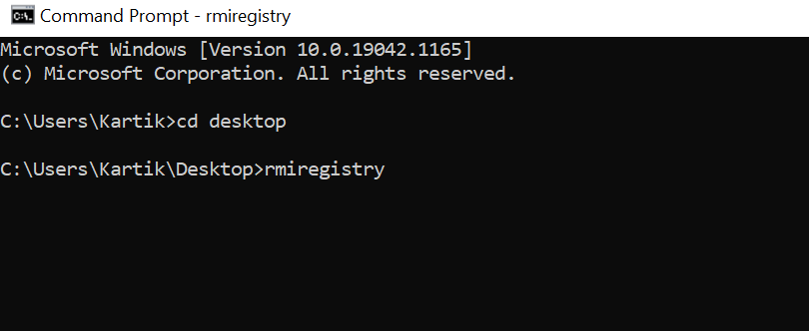

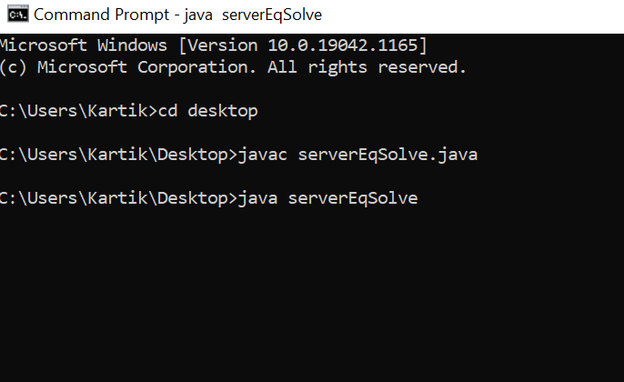

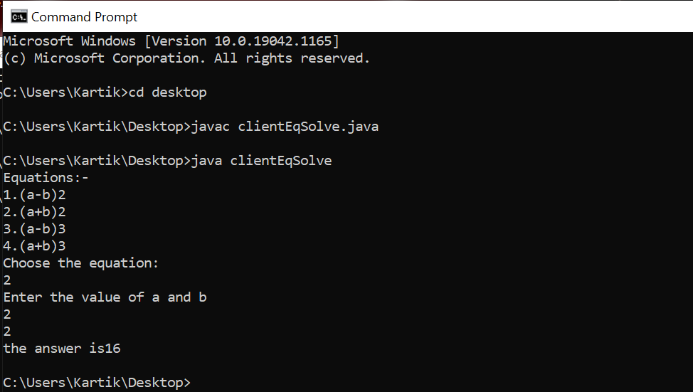

**PRACTICAL NO. 6**

**Aim:** Implementation of mutual exclusion using Token ring algorithm.

**Program:**

**TokenServer.java**

import java.net.*;

import java.io.*;

class TokenServer

{

public static DatagramSocket ds;

public static DatagramPacket dp;

public static void main(String[] args) throws Exception

{

try

{

ds=new DatagramSocket(1000); // ds is the object of DatagramSocket at port 1000

while(true)

{

byte buff[]=new byte[1024];

// data coming from client is in byte form. This data is stored in *buff* array

// this data is received at server through *ds*

dp=new DatagramPacket(buff, buff.length);

ds.receive(dp);

// data in byte form is converted in string form

String str=new String(dp.getData(),0,dp.getLength());

// the data received from client is display at server

System.out.println("Message from " +str);

}

}

catch(Exception e)

{

e.printStackTrace();

}

}

}

**TokenClient1.java**

import java.net.*;

import java.io.*;

class TokenClient1

{

public static DatagramSocket ds;

public static DatagramPacket dp;

public static BufferedReader br;

static int cp=100;

public static void main(String[] args) throws Exception

{

boolean hasToken;

try

{ ds=new DatagramSocket(100); }

catch(Exception e)

{ e.printStackTrace(); }

hasToken=true;

while(true)

{

if(hasToken==true)

{

System.out.println("Do you want to enter data...(yes/no):");

br=new BufferedReader(new InputStreamReader(System.in));

String ans=br.readLine();

if(ans.equalsIgnoreCase("yes"))

{

System.out.println("ready to send……….");

System.out.println("sending……………..");

System.out.println("Enter the data ");

br=new BufferedReader(new InputStreamReader(System.in));

String str="Client-1===> " + br.readLine();

byte buff[]=new byte[1024];

buff=str.getBytes();

ds.send(new DatagramPacket(buff, buff.length, InetAddress.getLocalHost(),

1000));

System.out.println("now sending……….");

}

else if(ans.equalsIgnoreCase("no"))

{

System.out.println("I am busy state……..");

//sending msg to client-2

String msg="Token";

byte bf1[]=new byte[1024];

bf1=msg.getBytes();

**ds.send(new DatagramPacket(bf1, bf1.length,**

**InetAddress.getLocalHost(), 200));**

hasToken=false;

//receiving msg from client-2

byte bf2[]=new byte[1024];

ds.receive(dp=new DatagramPacket(bf2,bf2.length));

String clientmsg=new String(dp.getData(),0,dp.getLength());

System.out.println("The data is "+clientmsg);

if(clientmsg.equals("Token"))

hasToken=true;

System.out.println("I am leaving busy state");

}

}

else

{

System.out.println("Entering in receive mode.");

byte bf[]=new byte[1024];

ds.receive(dp=new DatagramPacket(bf,bf.length));

String clientmsg1=new String(dp.getData(),0,dp.getLength());

System.out.println("The data is "+clientmsg1);

if(clientmsg1.equals("Token"));

{

hasToken=true;

}

}

}}}

**TokenClient2.java**

import java.net.*;

import java.io.*;

class TokenClient2

{

static DatagramSocket ds;

static DatagramPacket dp;

static BufferedReader br;

public static void main(String[] args) throws Exception

{

try

{ ds=new DatagramSocket(200); }

catch(Exception e)

{ e.printStackTrace(); }

boolean hasToken=true;

while(true)

{

if(hasToken==true)

{

System.out.println("Do you want to enter data(Yes/No):");

br=new BufferedReader(new InputStreamReader(System.in));

String str=br.readLine();

if(str.equalsIgnoreCase("yes"))

{

System.out.println("Enter Data; ");

br=new BufferedReader(new InputStreamReader(System.in));

String msg="Client-2===>"+br.readLine();

byte bf1[]=new byte[1024];

bf1=msg.getBytes();

ds.send(new DatagramPacket(bf1,bf1.length,InetAddress.getLocalHost(),1000));

System.out.println("Data sent");

}

else

{

//send to client 1.

String clientmsg="Token";

byte bf2[] = new byte[1024];

bf2=clientmsg.getBytes();

**ds.send(new DatagramPacket(bf2,bf2.length,InetAddress.getLocalHost(),100));**

hasToken=false;

}

}

else

{

try

{

byte buff[]=new byte[1024];

System.out.println("Entering in receiving mode.");

ds.receive(dp=new DatagramPacket(buff,buff.length));

String clientmsg1=new String(dp.getData(),0,dp.getLength());

System.out.println("The data is "+clientmsg1);

if(clientmsg1.equals("Token"))

hasToken=true;

}

catch(Exception e)

{

e.printStackTrace();

}

}

}

}

}

**Output:**

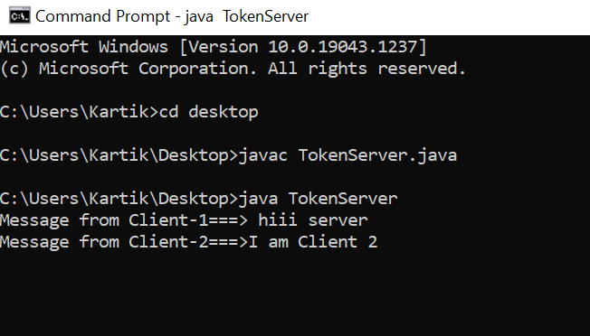

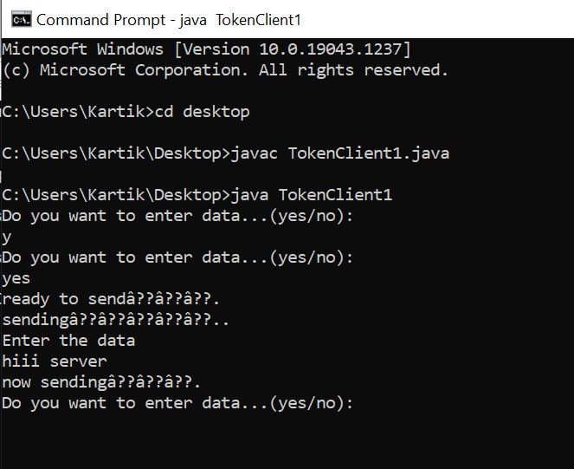

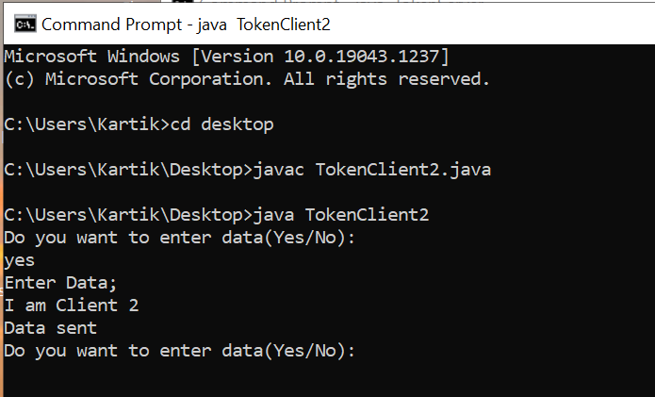

**PRACTICAL NO. 7**

**Aim:** Implementation of Storage as a Service using Google Docs.

**Steps:**

**Software as a service using Google Drive**

Agenda

* Introduction to Google Drive
* Share with Google Drive
* My Drive
* Shared Doodle Drives
* Google Drive tools and options

Introduction to Google Drive

Google Drive is gooles software as a service as part of productivity suite Google Drive helps you sharing files safely with your peers, collaborate real-time and organize your files quickely and easily.

**With Google Drive you can:**

* Create, add or upload a file with a single button.
* Find and add files shared with you more easily.
* Drag-and-drop files and folders just like you do on your desktop.
* Access your files from any of your devices.

**Common use cases for google derive:**

* Access and edit your work files anywhere
* Share files with a team and department
* Store and search all of your company’s files.
* Collaborate with co-workers and partners in real-time.

**My Drive**

* My drive represents content that you own and content that you have permission to access.
* When content is created in my drive the creator owns the content.
* Owners can

Move files and folders

Add collaborators with edit comment or view permission

Share a link to a file or folder d

Delete content and restore it from the trash.

**Share Google Drive**

* Share drives are shared spaces in google drive for sharing content with a team instead
* The content in a shared drive In owned by the team
* As people join and leave a team the content remains accessible in the shared drive
* Share drives have more collaborator roles and more options for granular access to files and folders

**Common use cases for shared Drive**

* Project file repositories
* Employee onboarding
* Training resources
* Scenarios where the entire company needs access to the same files

**Share Google Drive – Permissions**

Shared drive permission are more granular than the option available when sharing files or folders from my drive

**Permission for shared Driver**

**Manager:** Have full access to the shared drive and can change its setting along with managing members and deletion of content

**Content manager** can perform most file level tasks except permanently delete content

**Contributors** can create have permission to create new files and folders but not organize content

**Commenters** can only provide comments

**Viewers** can only view content

Each shared drive has its own trash and content is permanently removed from the trash after 30 days to restore a deleted files or folder

**Google Drive tools and options**

Google drive offers several additional tools add-ons and options that can be enabled to help meet your needs

**Offline viewing drive:** it’s possible to work in google drive without an active internet connection to make your google docs sheet and slides available offline on your device. This is done by installing a google drive offline extension to the browser. All the selected files can available for offline and any changes made to the file while offline will be sync when the internet is restored.

**Google drive file stream:** allows you to work from your desktop with files stored in the cloud the files are available on demand which means they don’t require space on your device’s storage nor do they require an enormous amount of bandwidth or download time this feature allows you to choose which files and folders are stored for offline access there are drive file stream application for Microsoft windows and mac os. Drive files stream also supports real-presence when editing Microsoft offline files.

**Google workspace marketplace:** an online store for application that work with google workspace for example google docs doesn’t have built-in mail merge feature but several apps in the google workspace marketplace can enable mail merge in google docs there are add-ons related to productivity communication accounting legal marketing task management and many more

**PRACTICAL NO. 8**

**Aim:** Implementation of Identity Management.

**Steps:**

* Open the following link <https://aws.amazon.com/>
* Go to my Account-> AWS management console

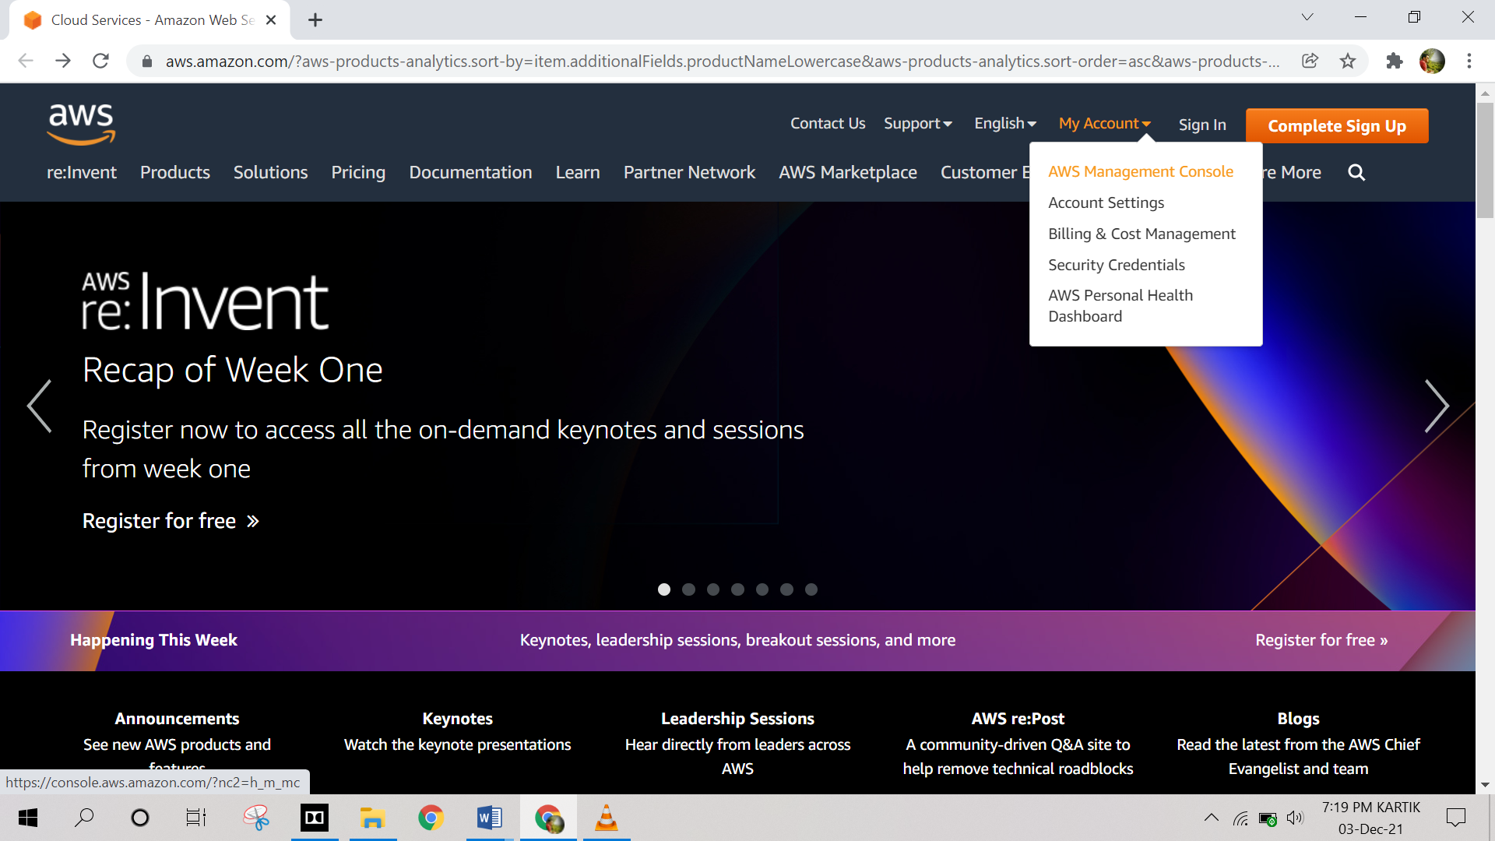

* click on Create new user AWS account

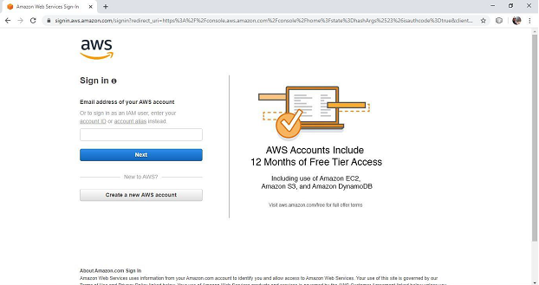

* Fill all the details and click on Continue

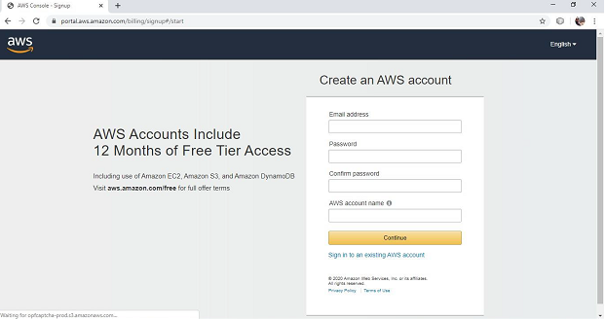

* Fill your contact number and Home address and click on create account and continue
* Now most curtail step AWS will ask for credit card and debit card details. You have to close the browser
* now again open the link <https://aws.amazon.com/>
* Go to my Account->AWS Management console
* Enter your ID and click on next, After that enter password and click on signin.

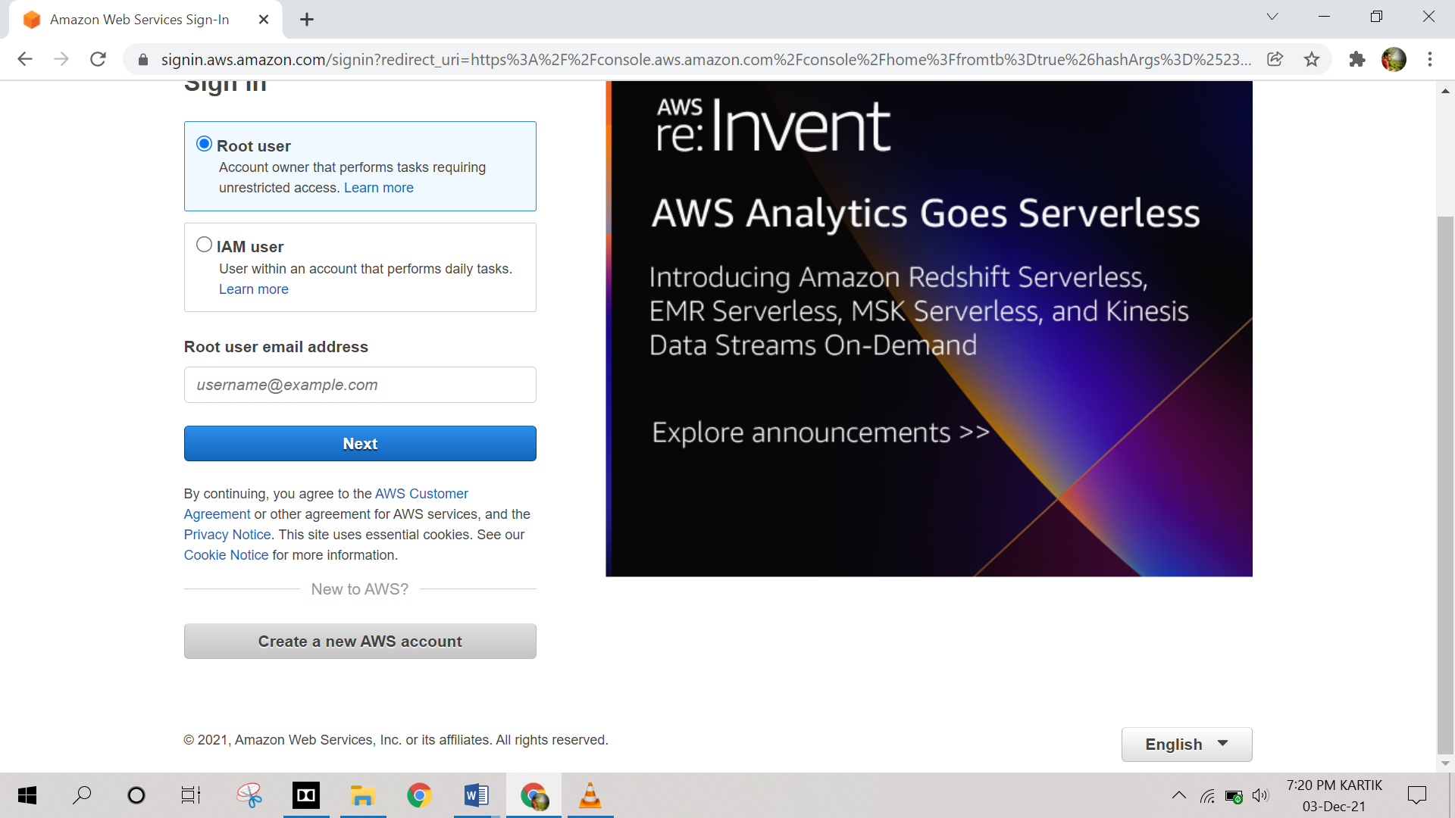

* you will get the following screen

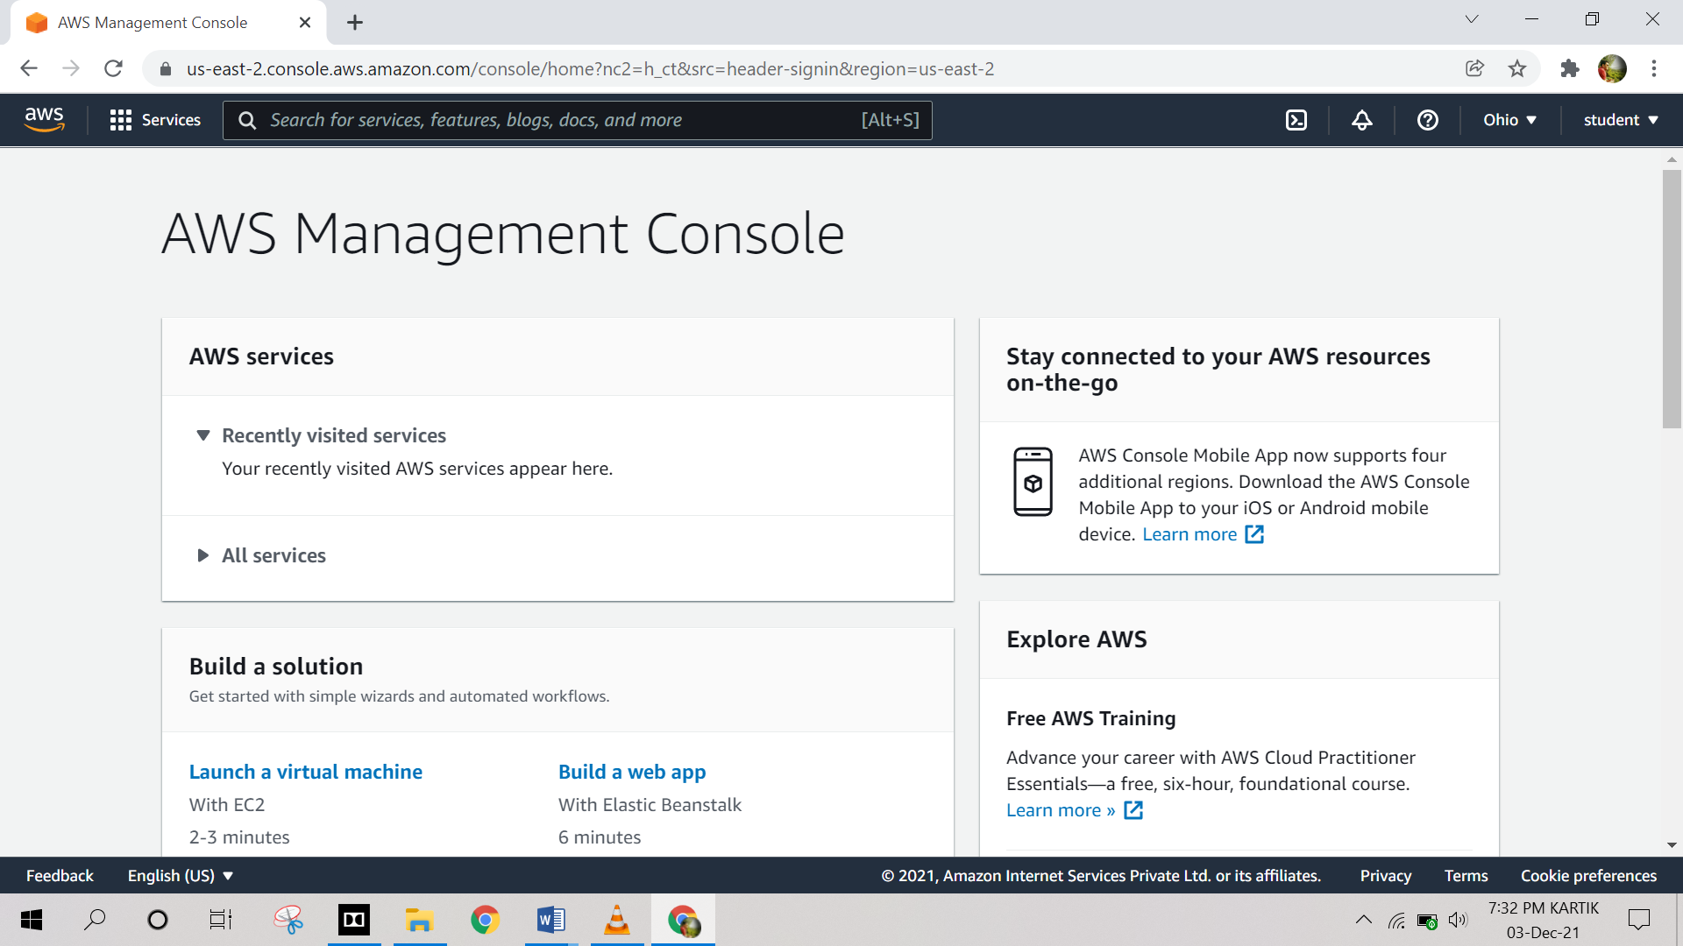

* Go to My Security credential

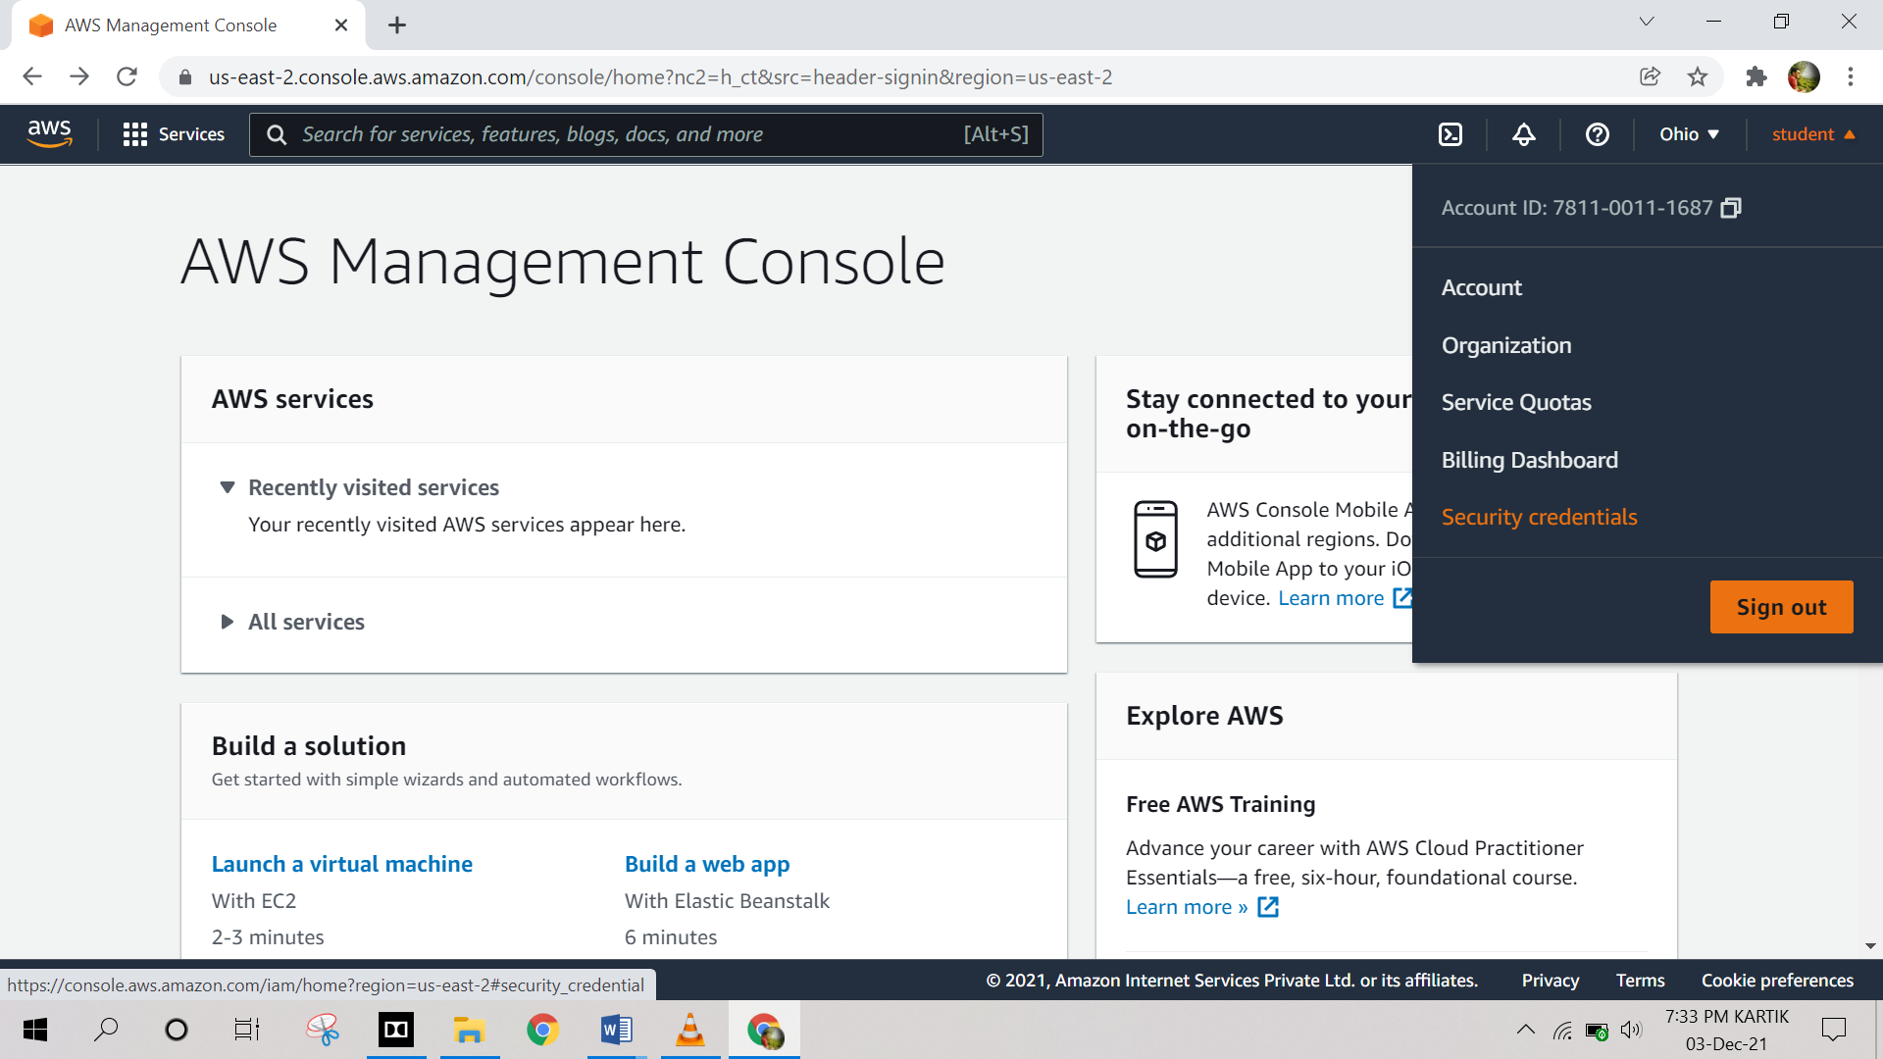

* now click on user

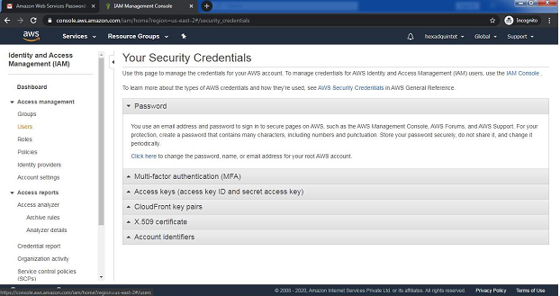

* Click on add user

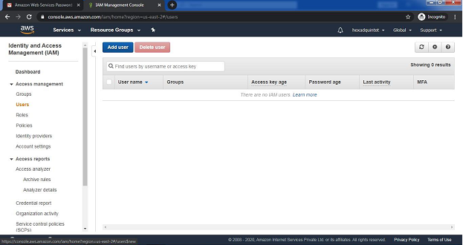

* Provide the user name and check the check box in front of programmatic access and AWS Management console Accessand enter the password for new user Click on custom password and click on next permission

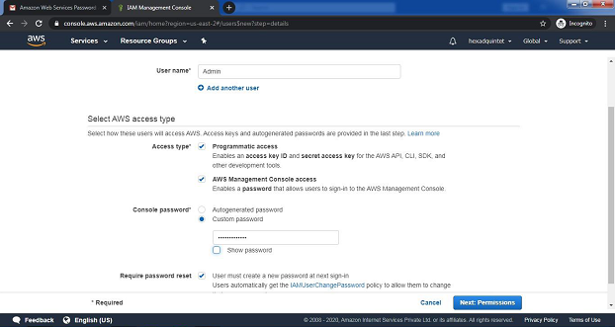

* click on create Group

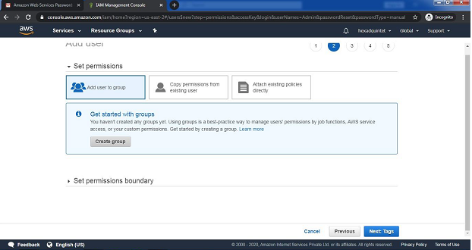

* fill the information and click on Create Group

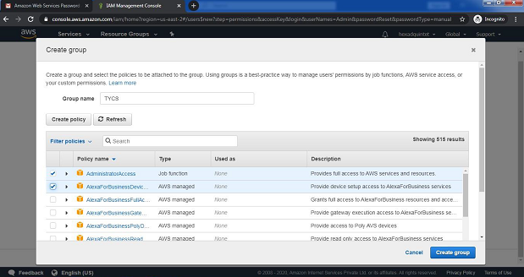

* click on next tag leave blank , again click on next review leave as it is and click on create user



* click on close

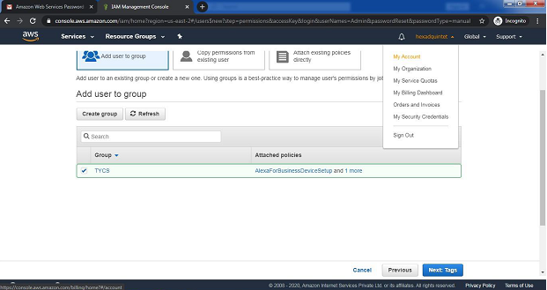

* And COPY Account ID



* Now logout the admin account and try to login as user(newly created) .
* again Go to my Account->AWS Management console

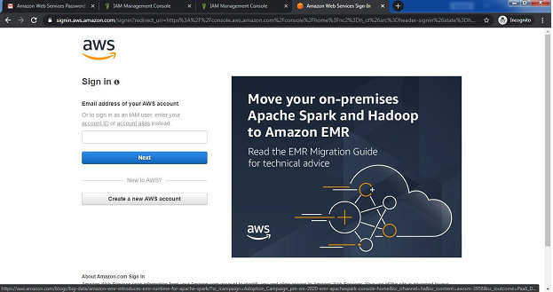

* Click on next Provide the Account ID username and password and click on sign in
* It will ask you to change the password which is been set by administrator

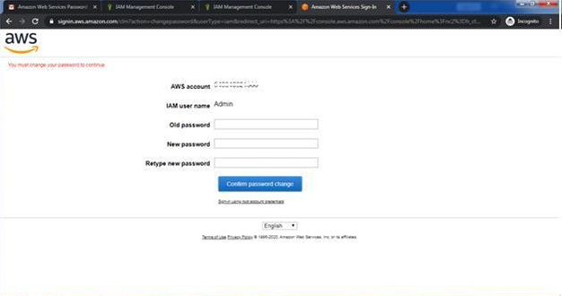

* Yow will redirect to home screen

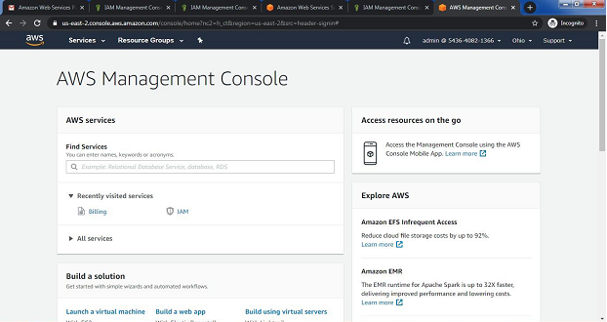

**Conclusion:** Hence we have studied the concept and implementation of identity management using amazon aws.

**PRACTICAL NO. 9**

**Aim:** To develop Application for windows Azure / Amazon AWS using Windows Azure Platform Training Kit and Visual Studio.

**Step 1:**

To develop an application for Windows Azure on Visual Studio 2019, install the Visual Studio 2019

**Step 2:**

* Open Visual Studio 2019
* Click on create new project

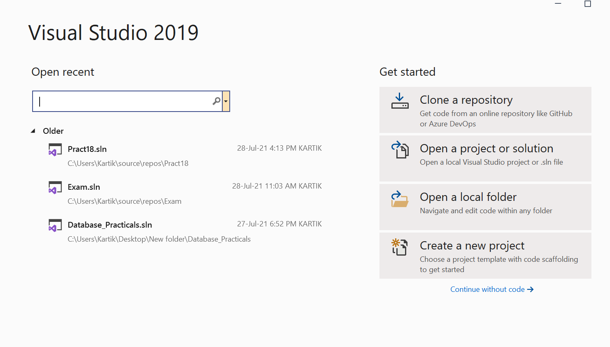

* After clicking on Create new project , a New Project Window will open

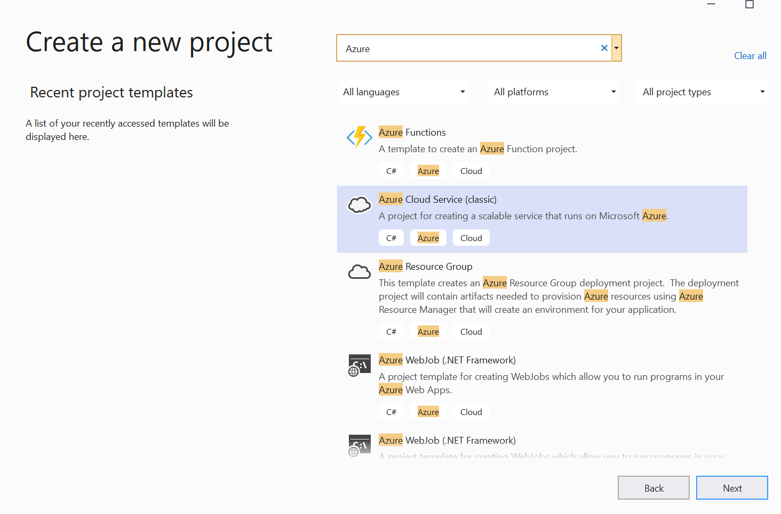

* In above window, choose Language as C#, Platform as Azure, Project as Cloud.
* Then select Azure Cloud Service(classic) option
* Click Next
* Configure project window will appear.

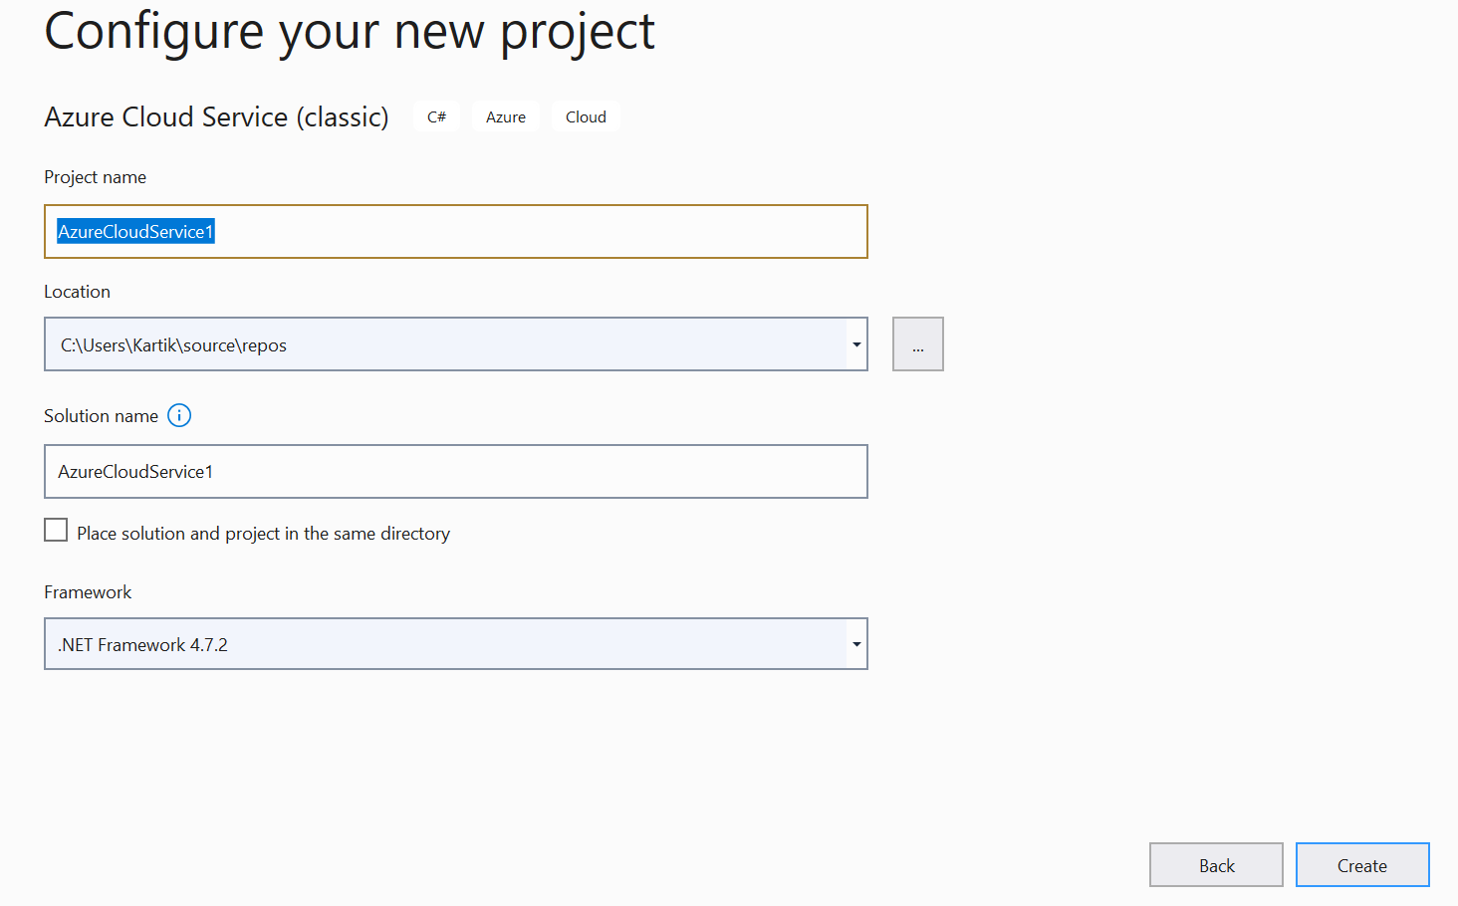

* Enter Project name(AzureCloudService1), then click on Create button.
* New Microsoft Azure Cloud Service(Classic) window will appear as below. Select Visual C# -> ASP.net Web Role.
* Click on > button for add role to solution.

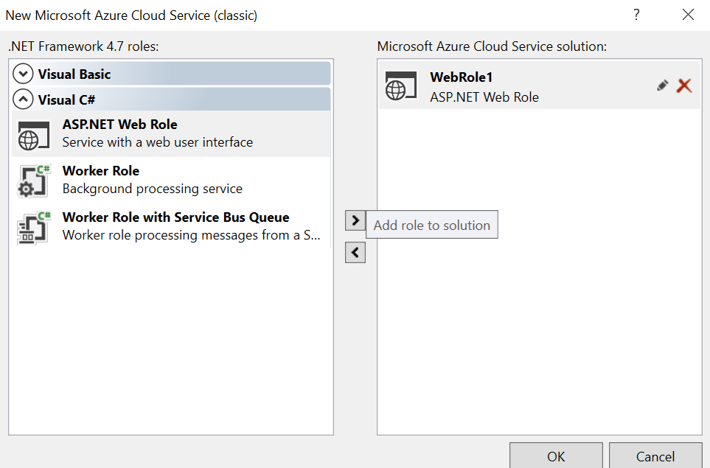

* Click on OK button.

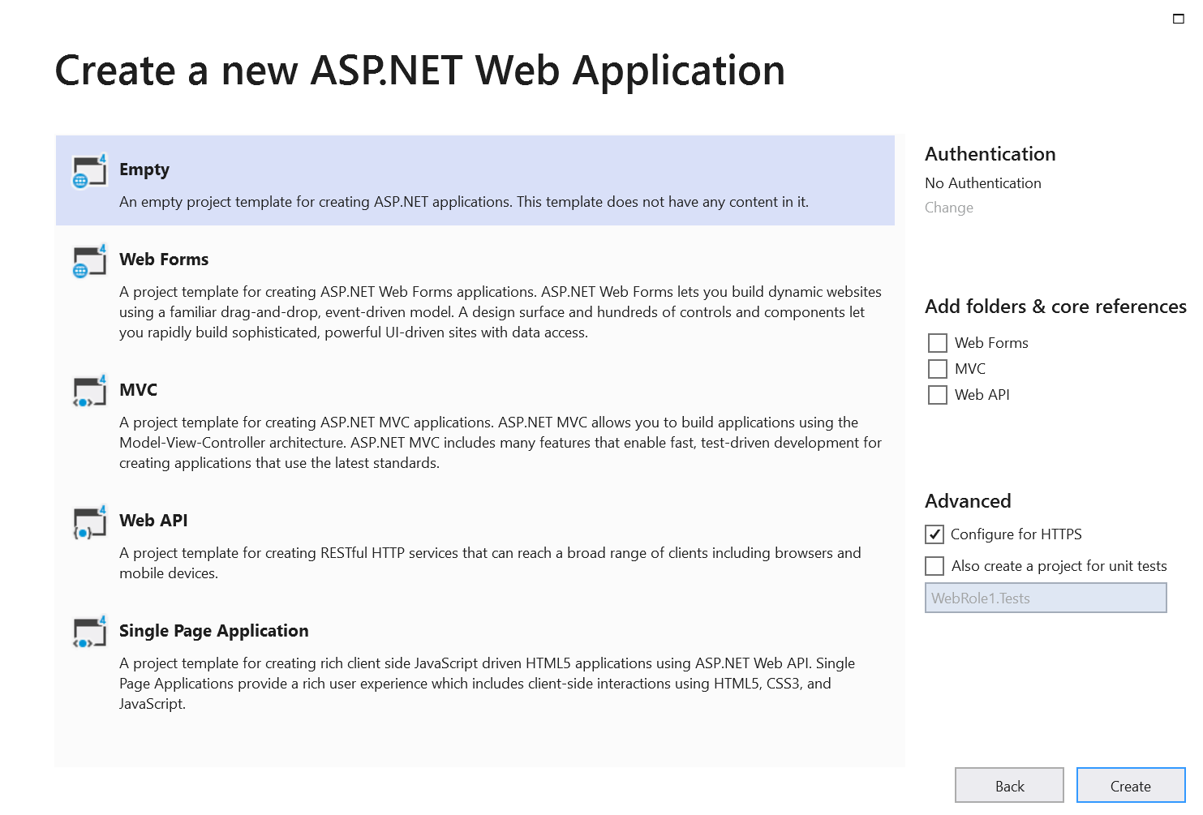

* Select Empty Option for creating empty project template and then click on Create Button. Below window will appear.

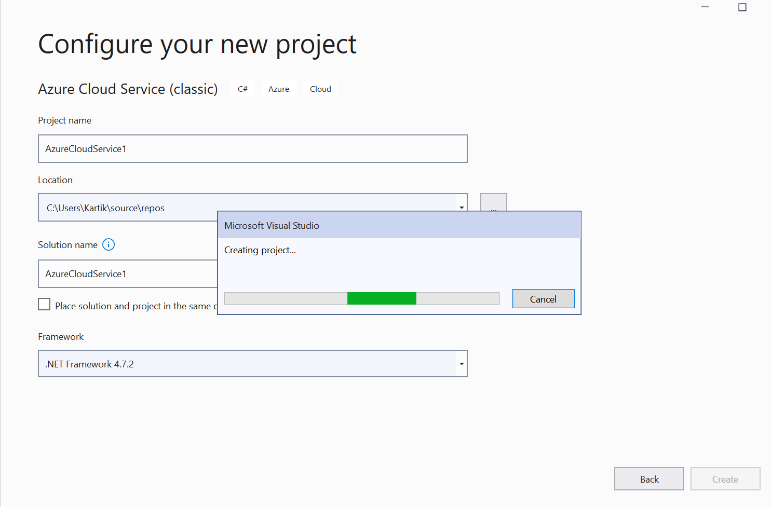

* Right Click on WebRole1 in Solution Explorer Window.

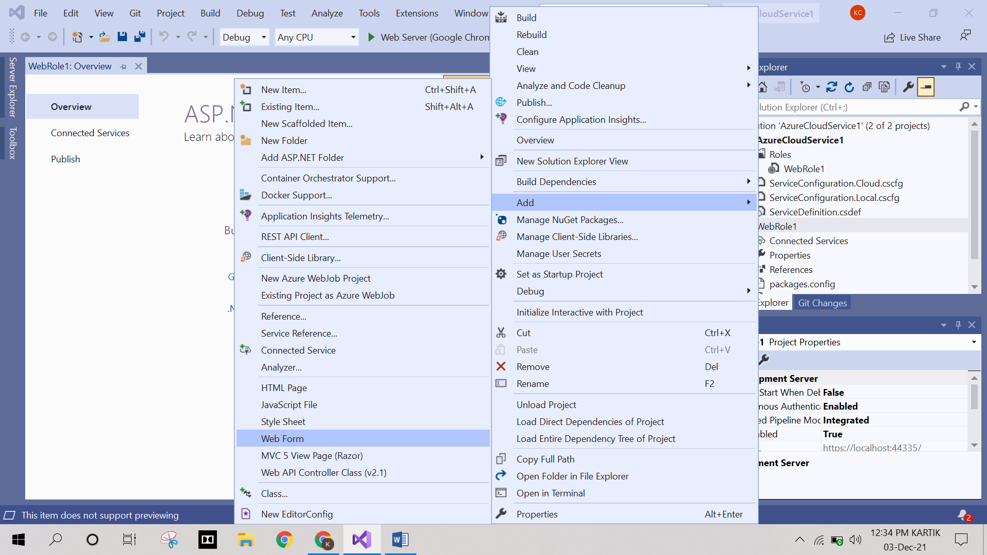

* Then click on Add Button--🡪Select Web Form
* Give Name to Web Form
* Click on OK Button.
* Below window will appear.
* Write one line code

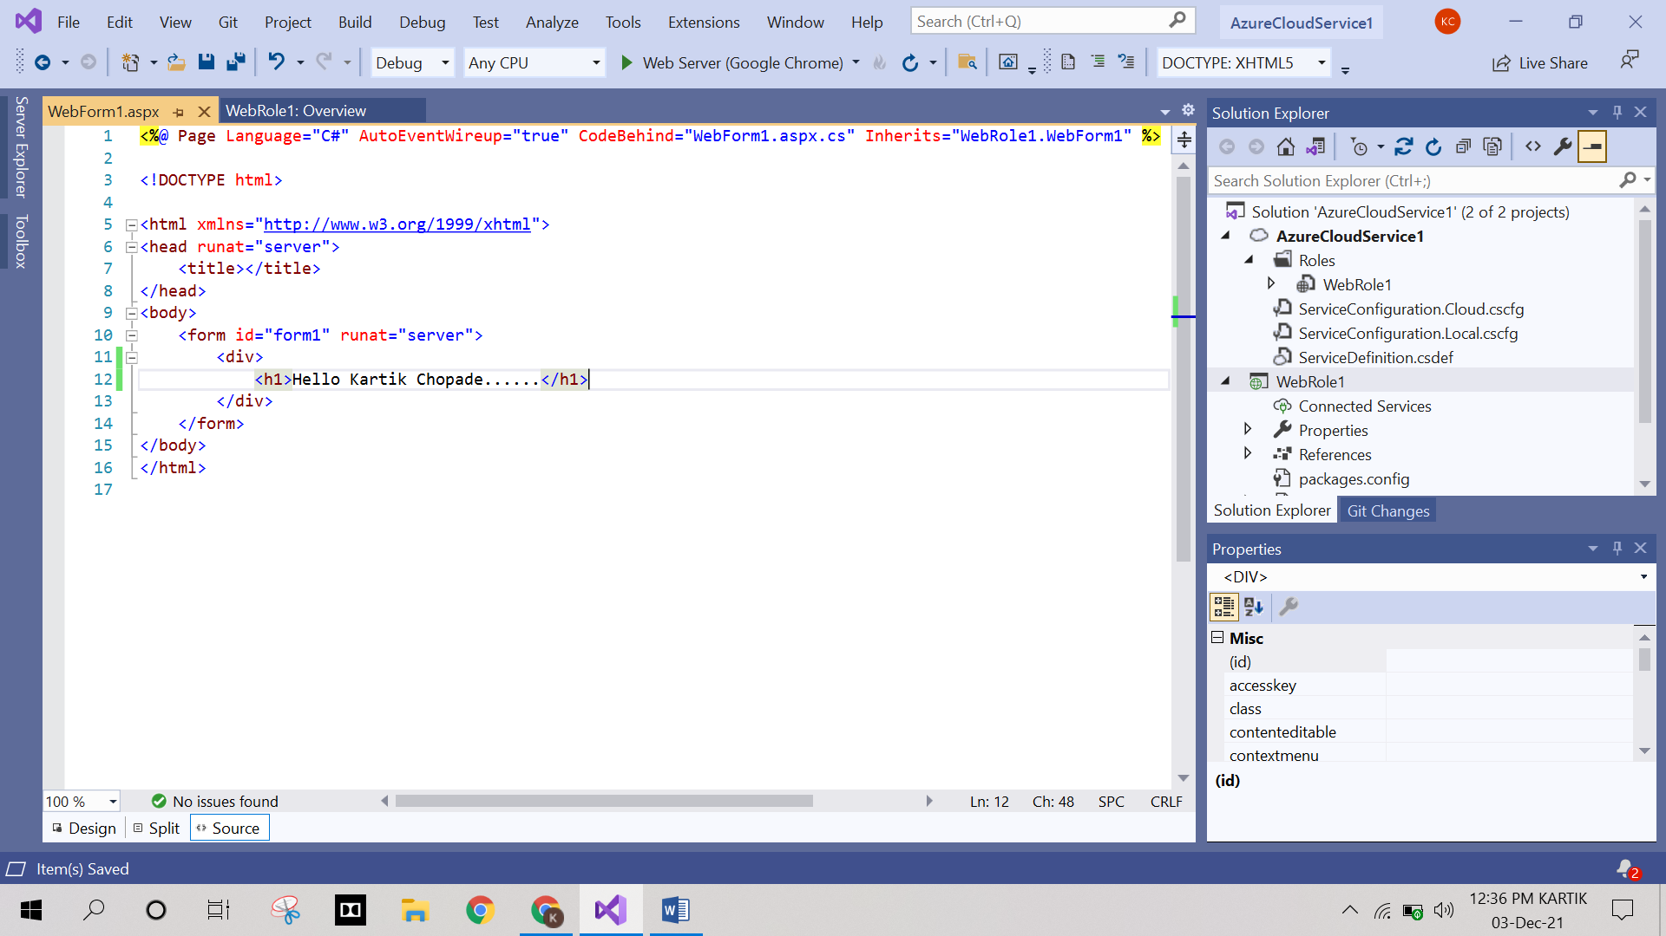

* Then click on Debug and Execute Project.

**Output:**

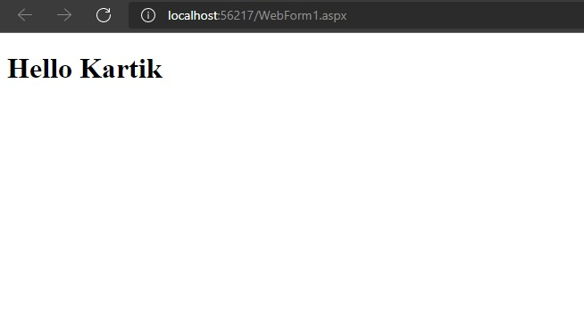

**PRACTICAL NO. 10**

**Aim:** To develop applications using Google App Engine by using Eclipse IDE.

**Steps:**

* Open Google Cloud Platform

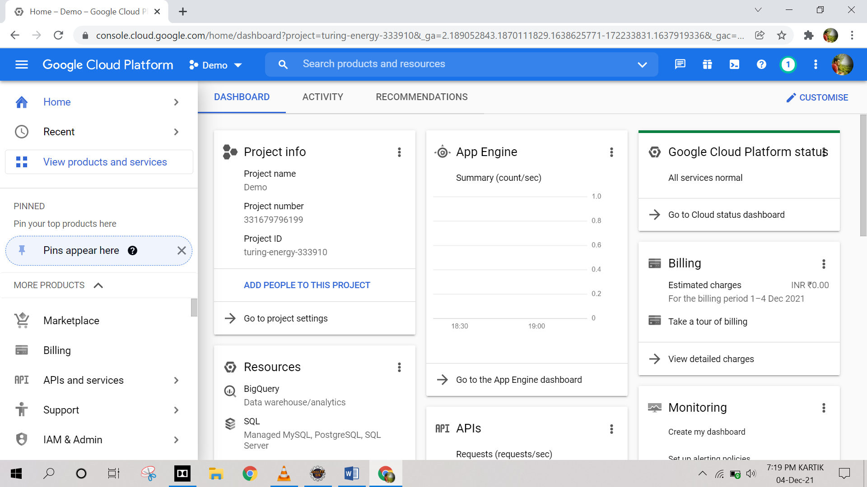

* Create New Project

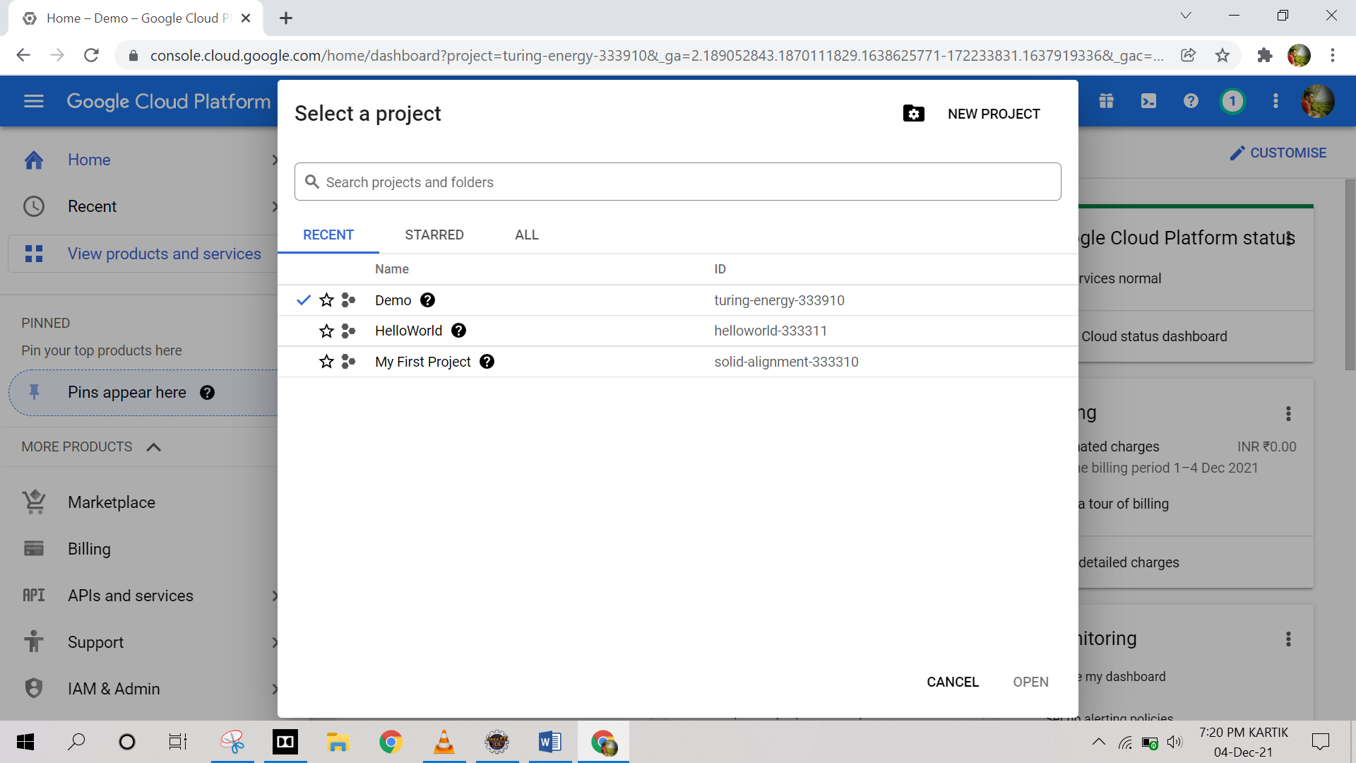

* Click on New Project
* Give name Demo

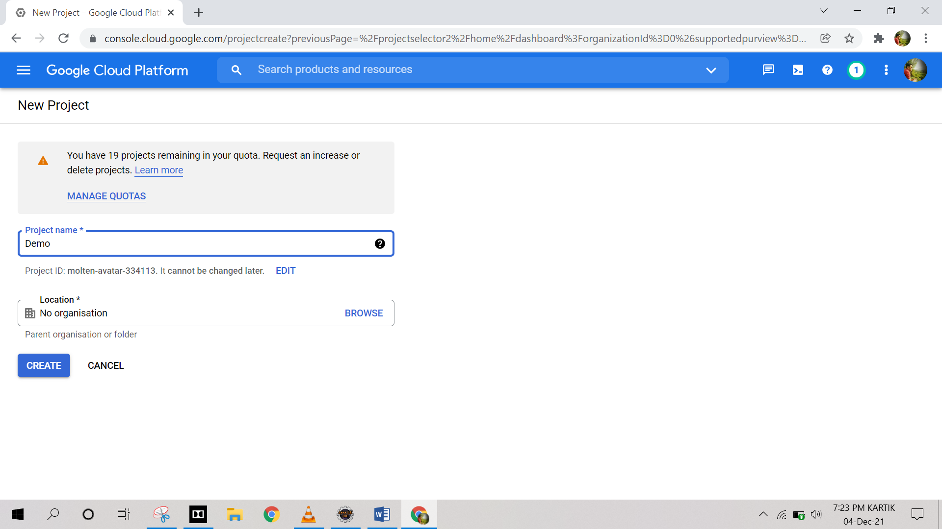

* Click Create button
* Your project is created

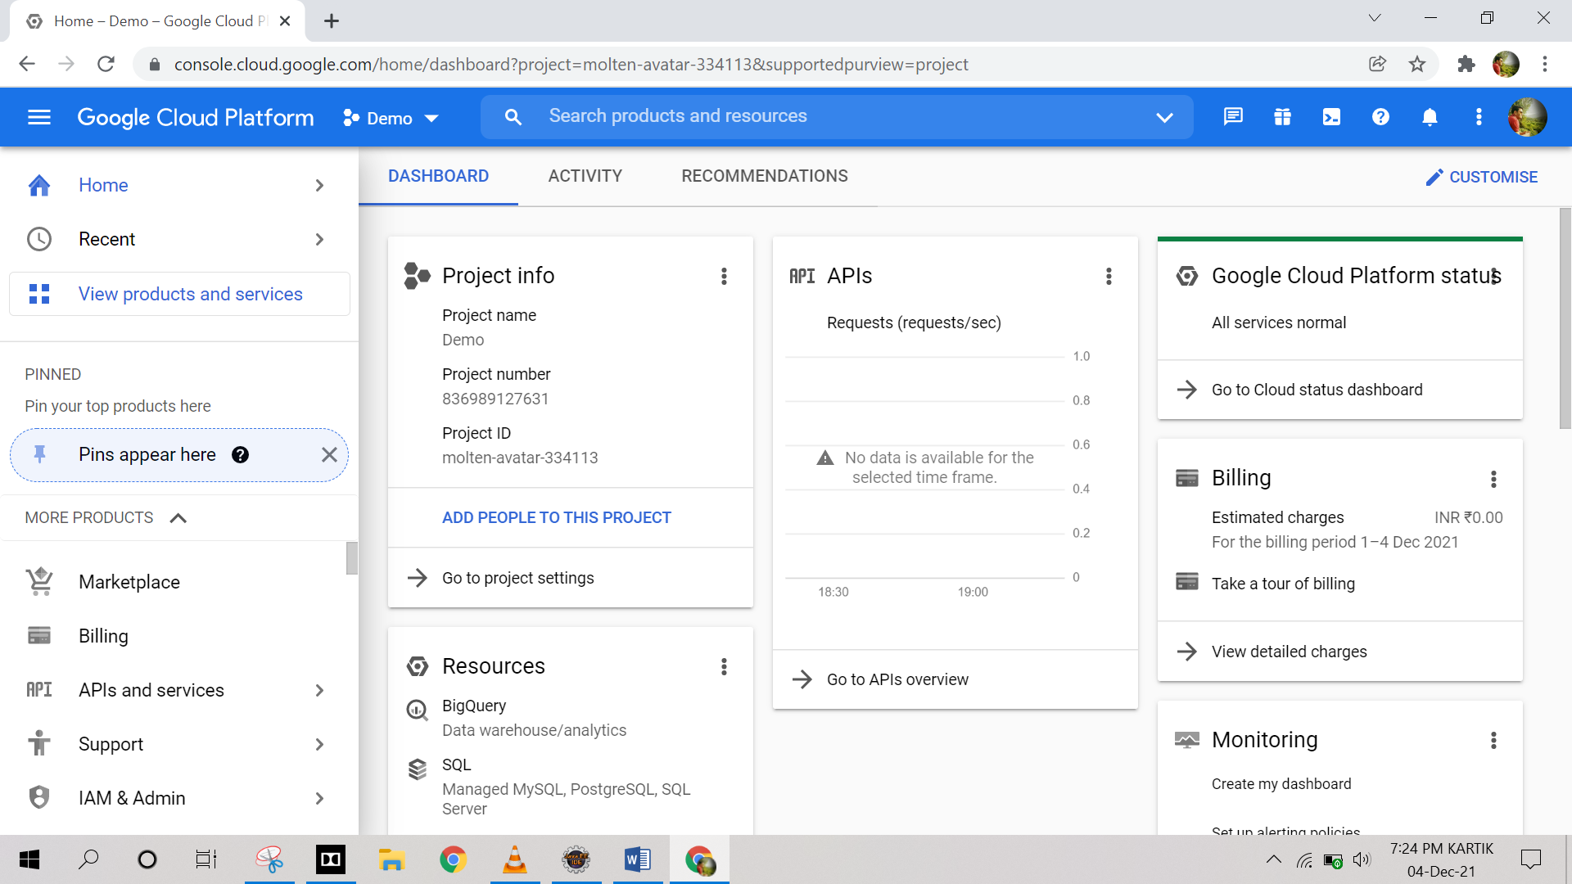

* Now click on App Engine

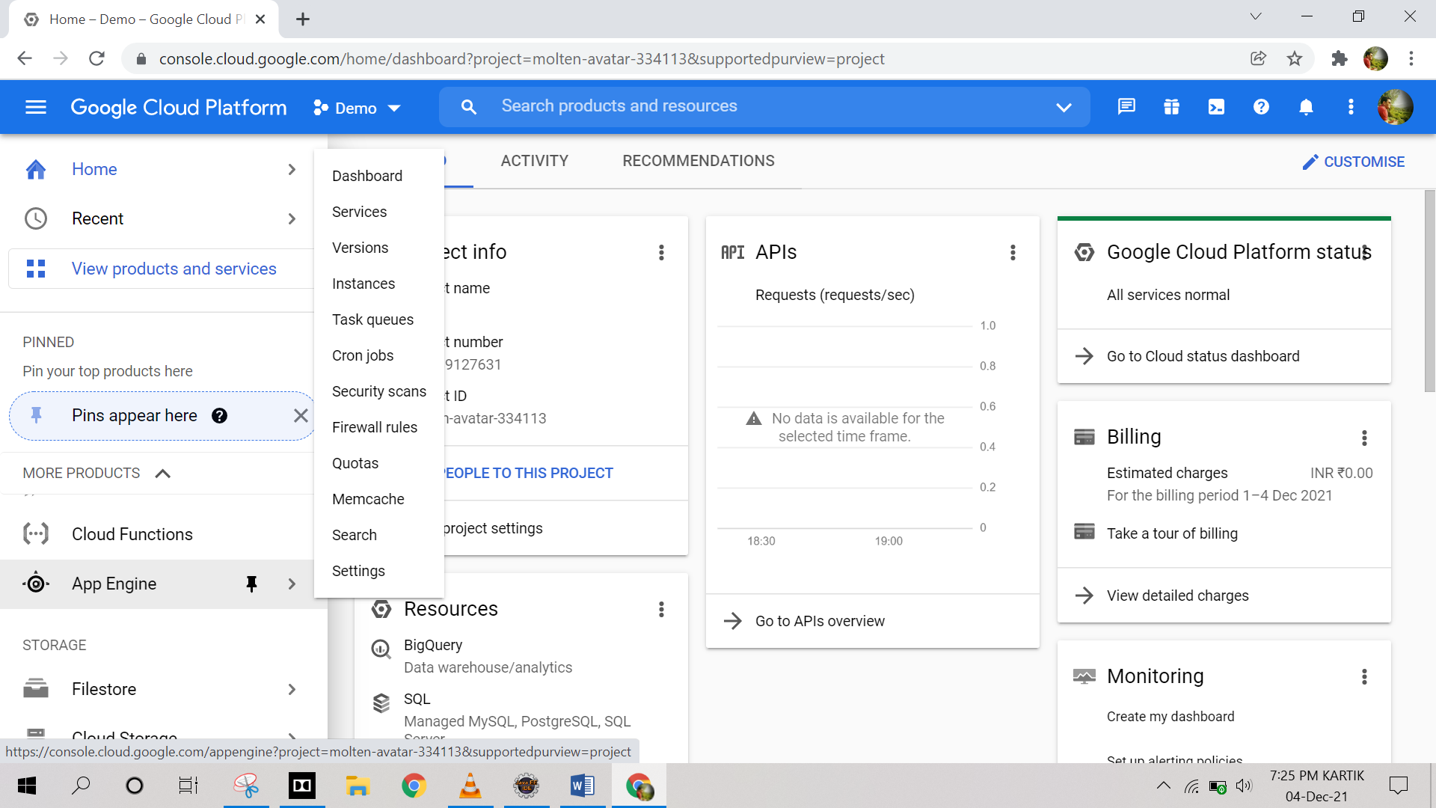

* Click on Create Application button

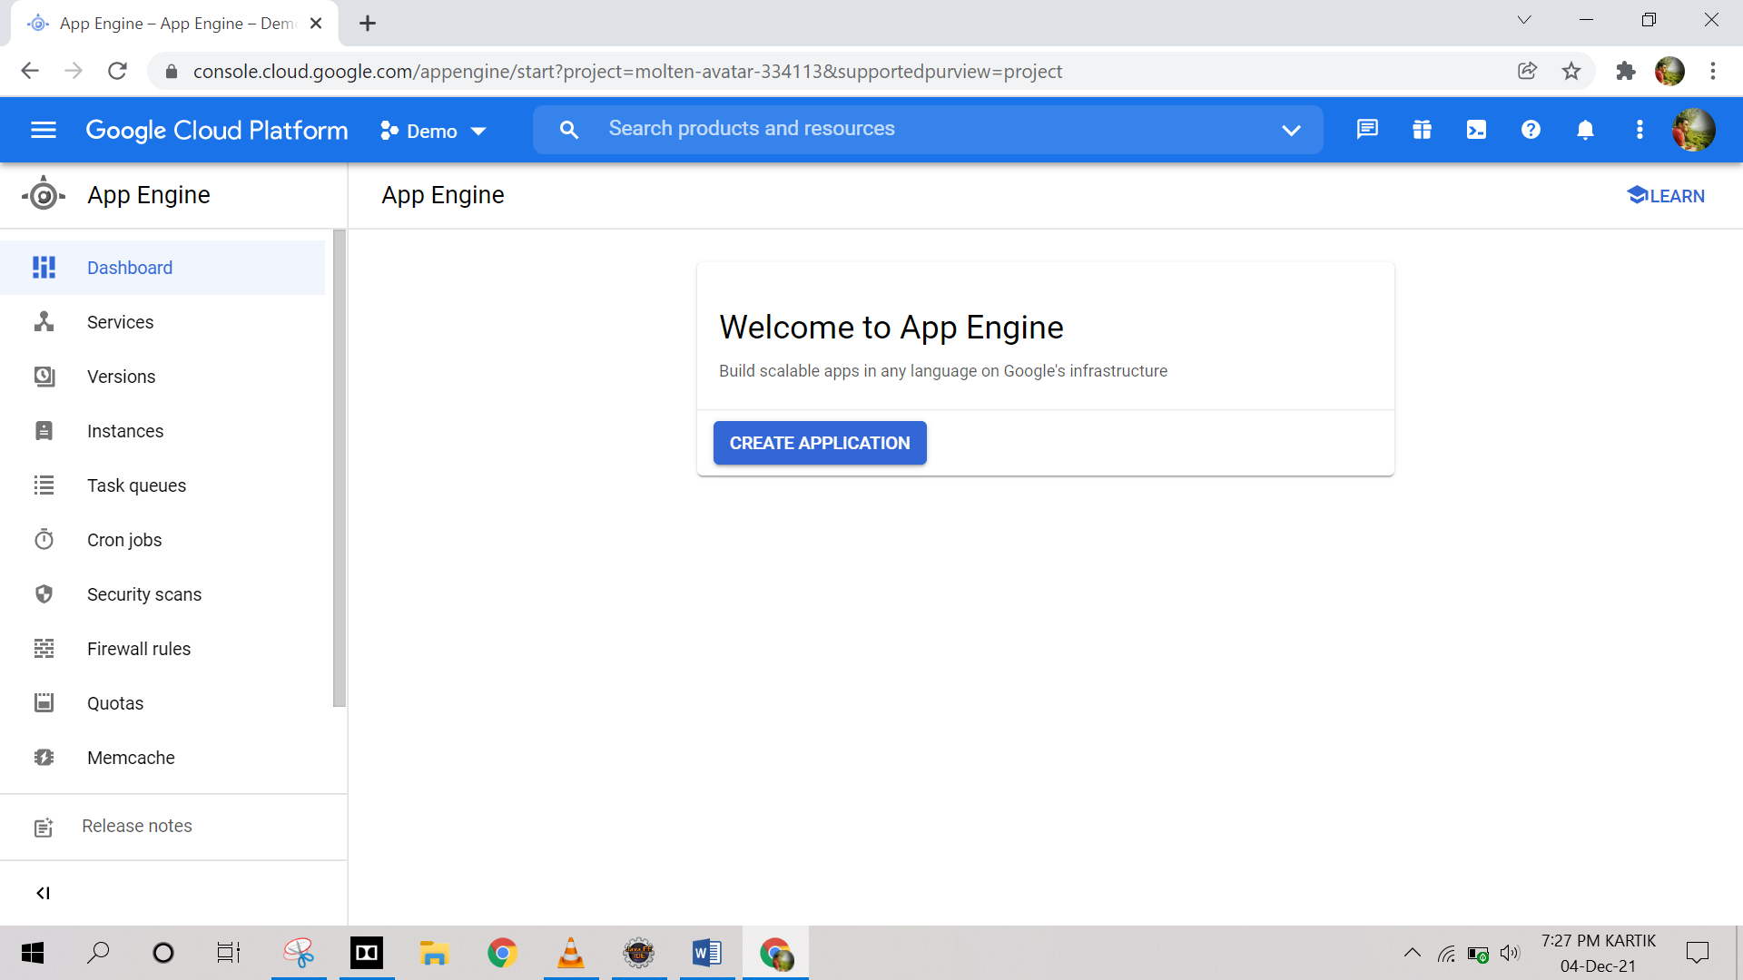

* Select India and click next

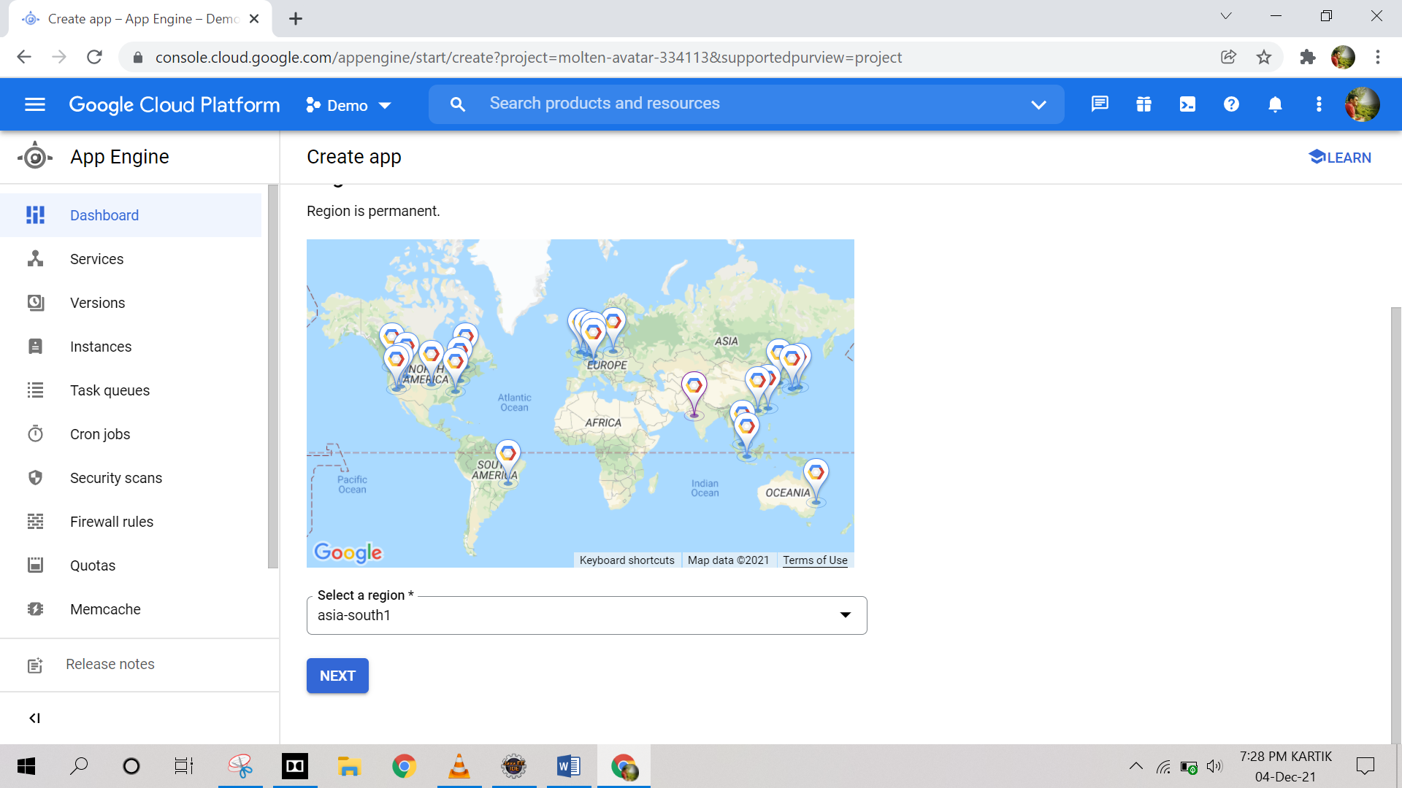

* Select Language java and set Environment Standard

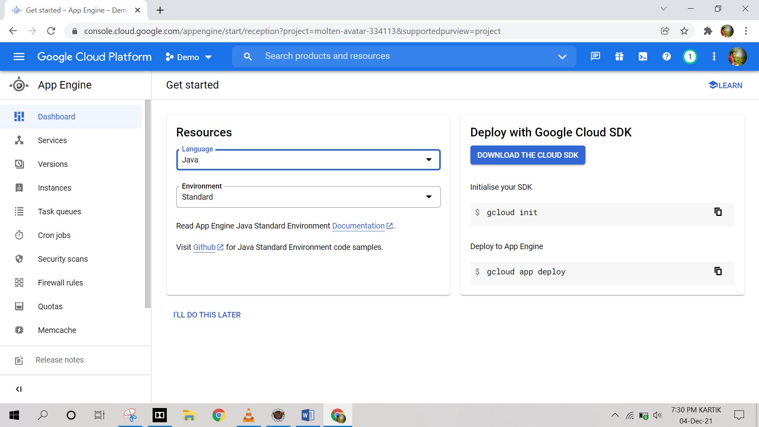

* Go to your Dashboard

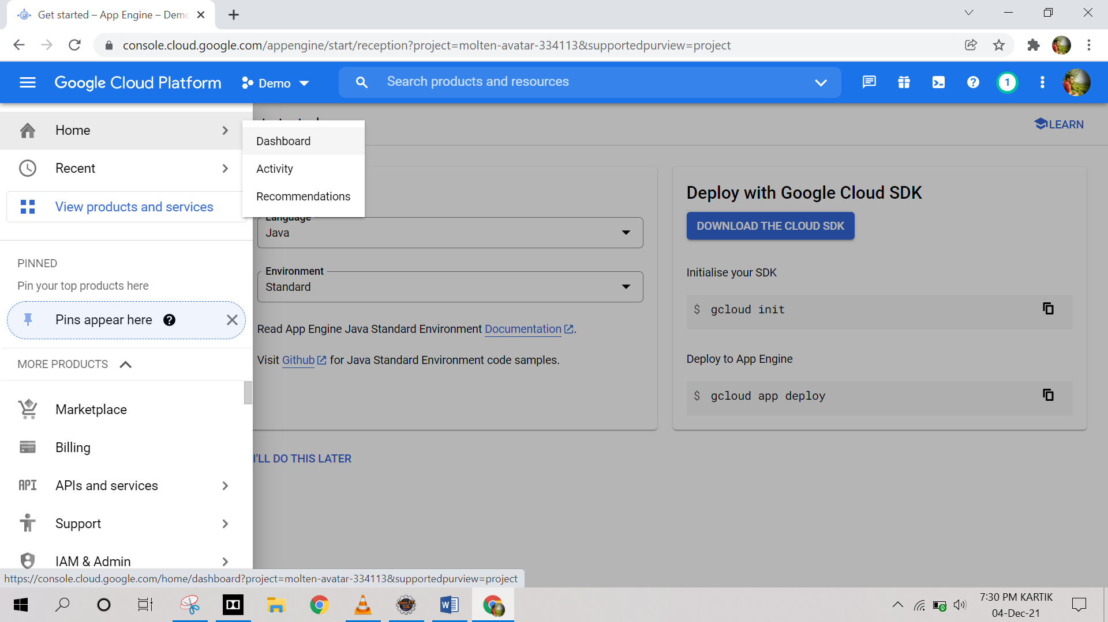

* Now Go to Eclipse
* Click on File --🡪New ---🡪Other
* Search Google
* Select Google App Engine Standard java project click on Next

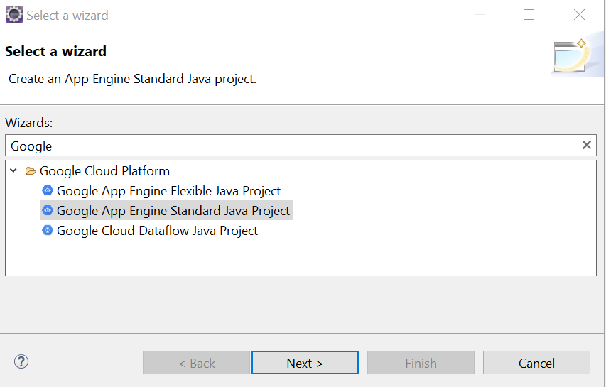

* Give prject name Demo and Give package name com.demo and Give product id(GCP id) and clck next

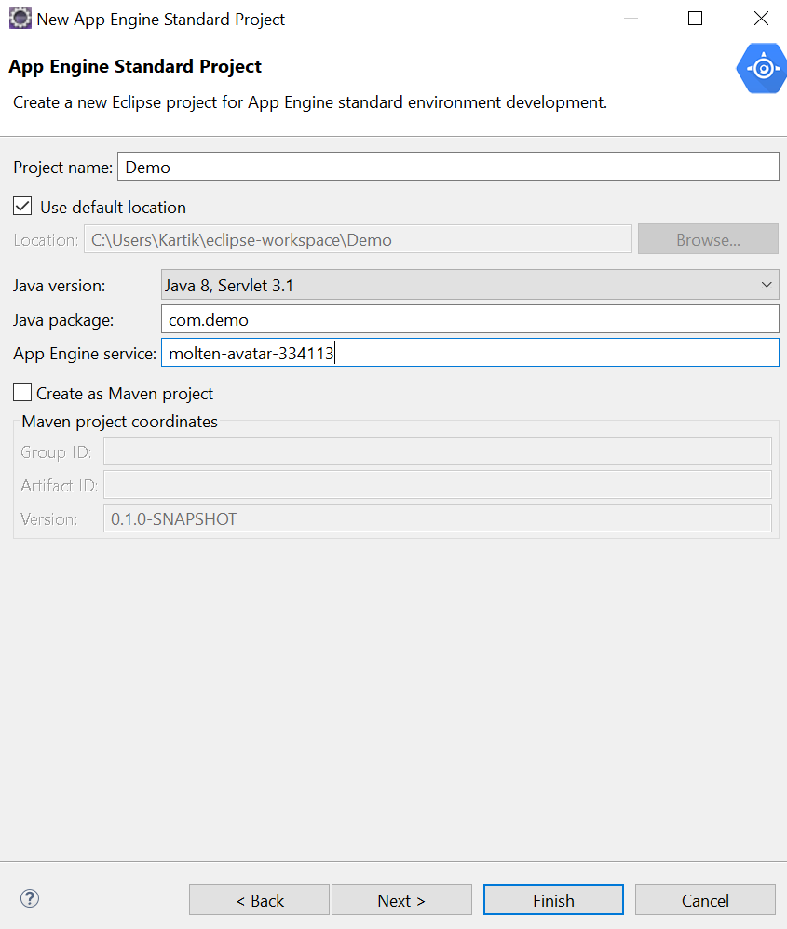

* Select two check boxes is given below

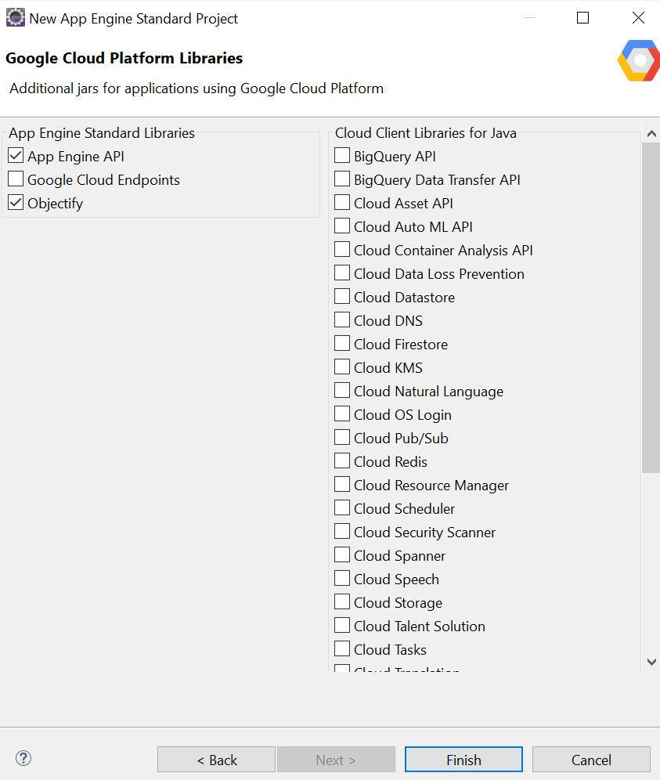

* Click on finish button
* Now run your project

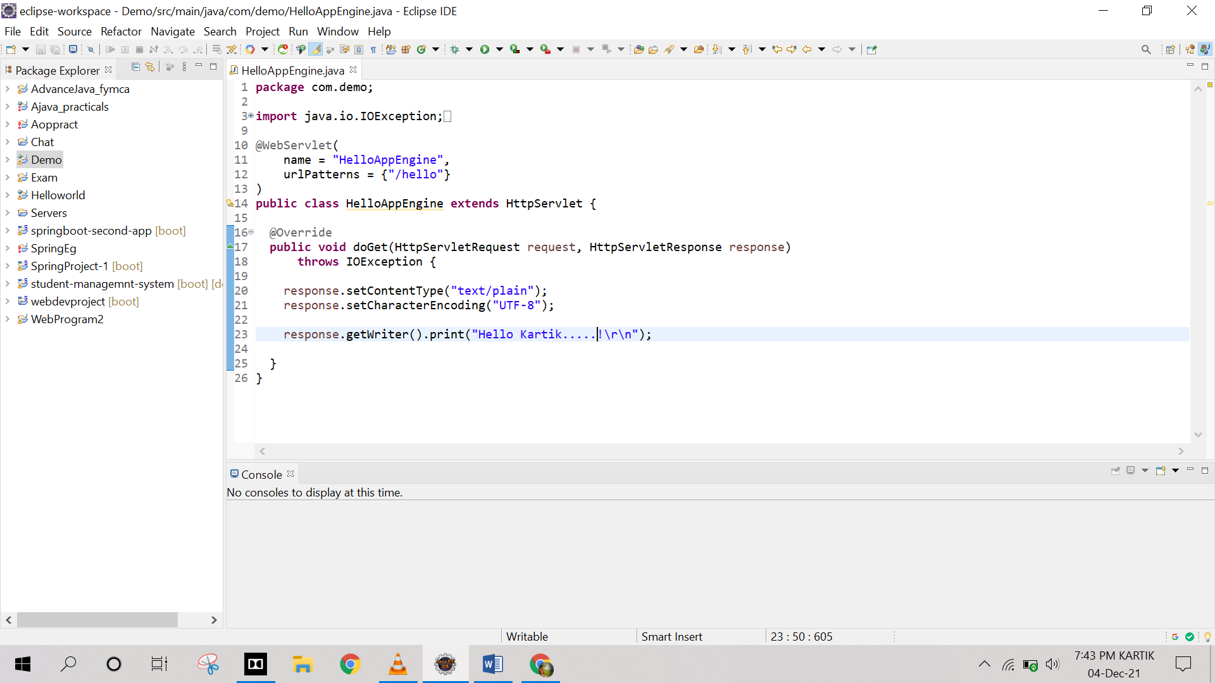

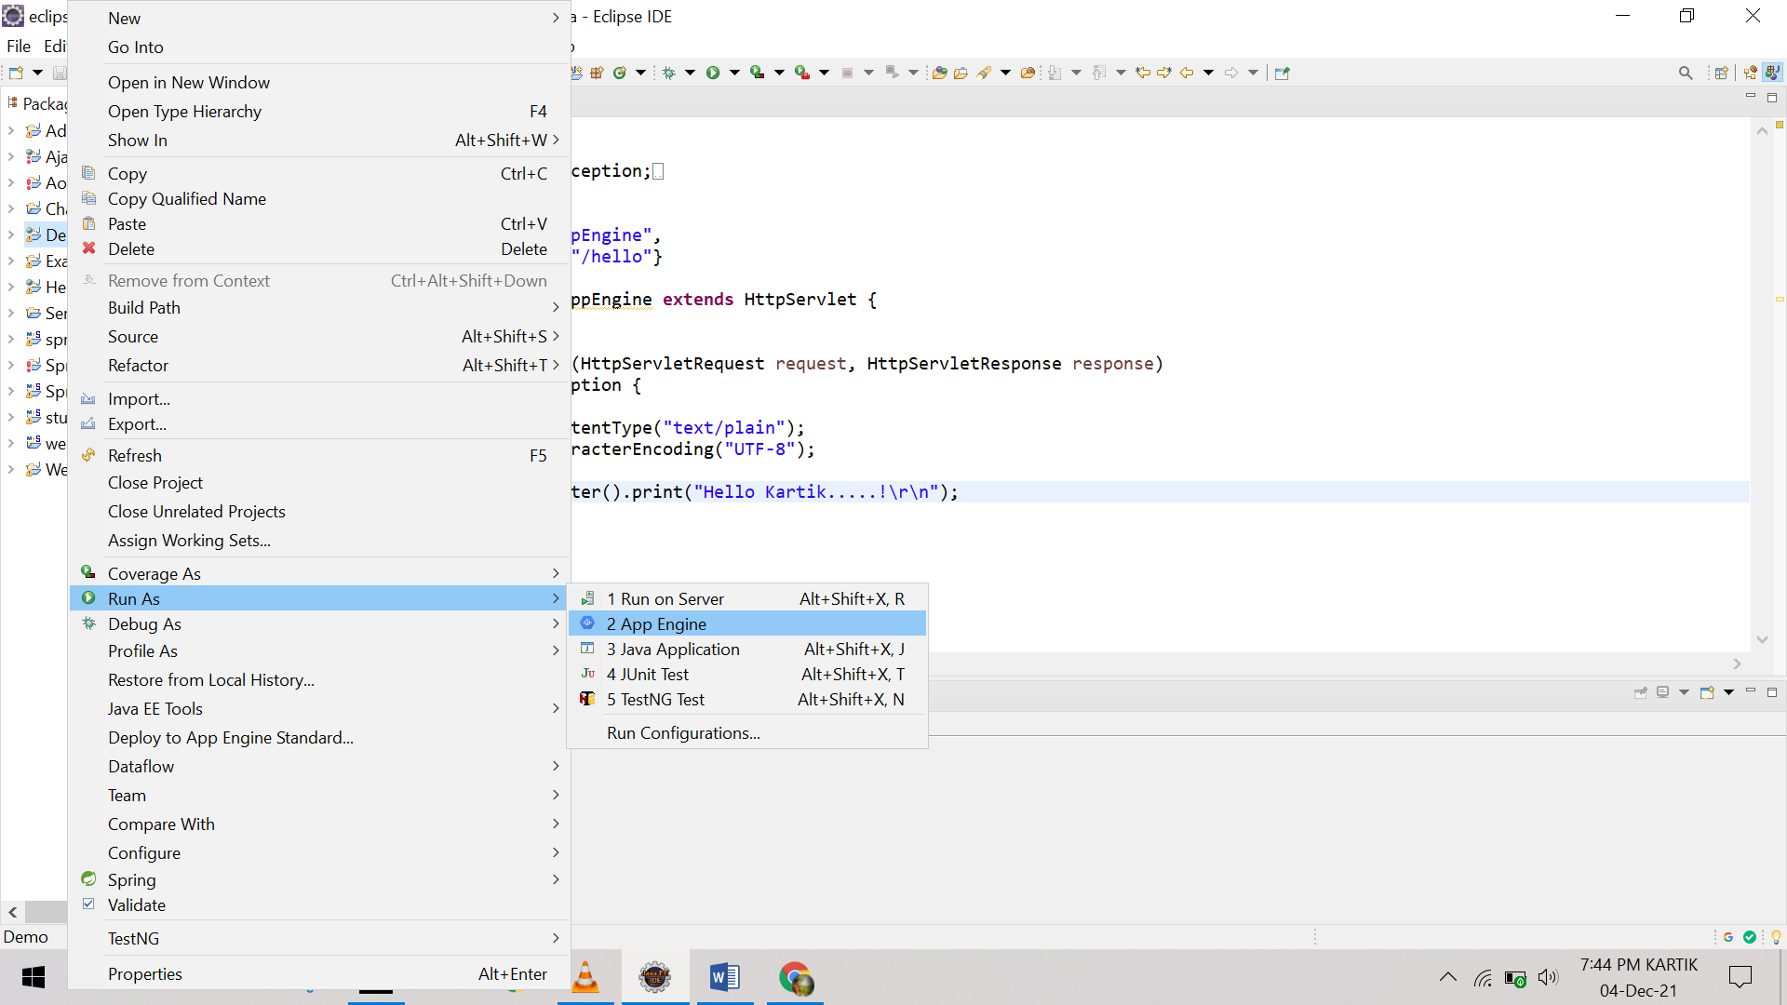

**Output:**

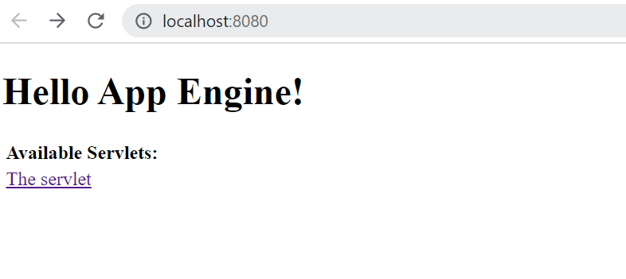

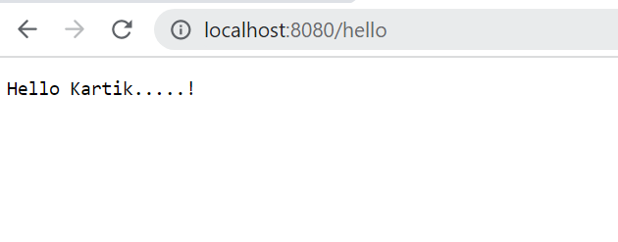

* Next Upload your project on Google cloud platform
* Right Click on your project and Click on Export

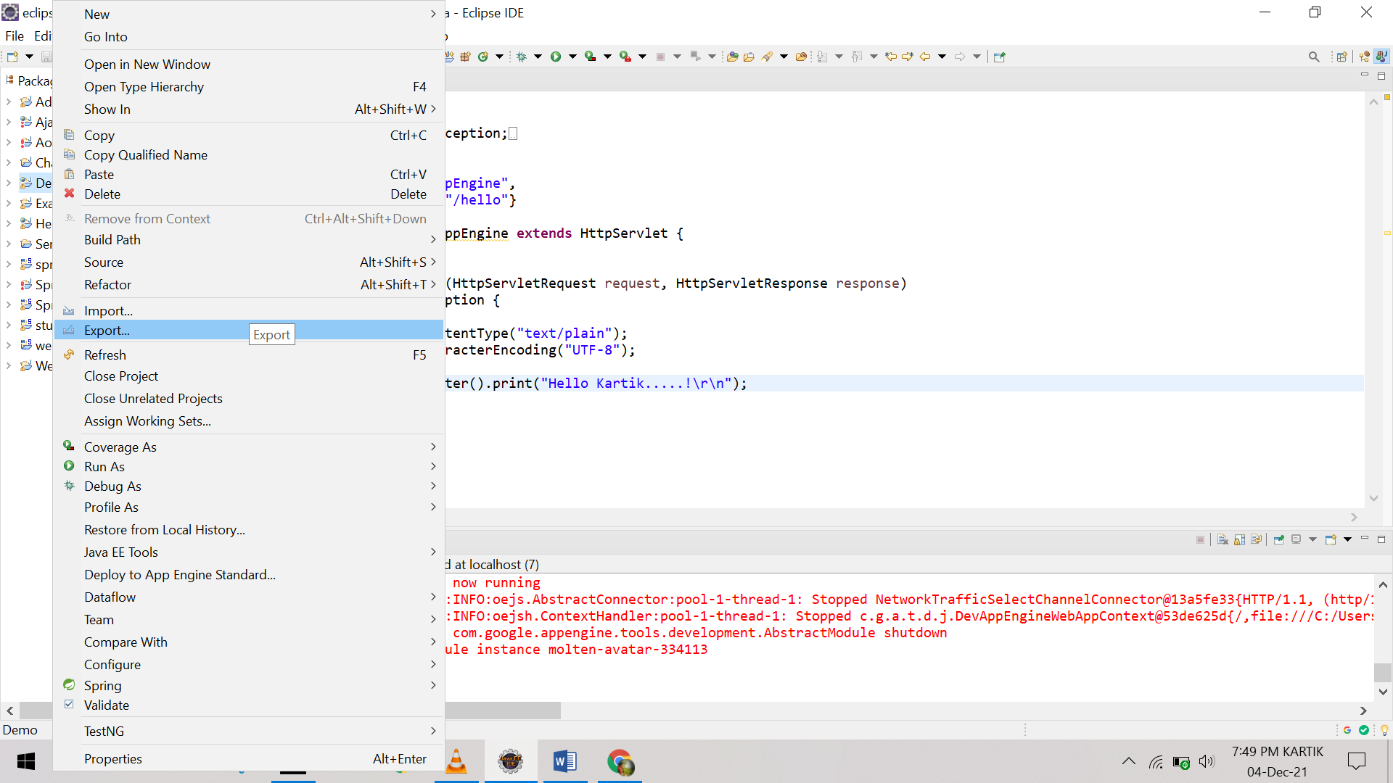

* Search War in search box

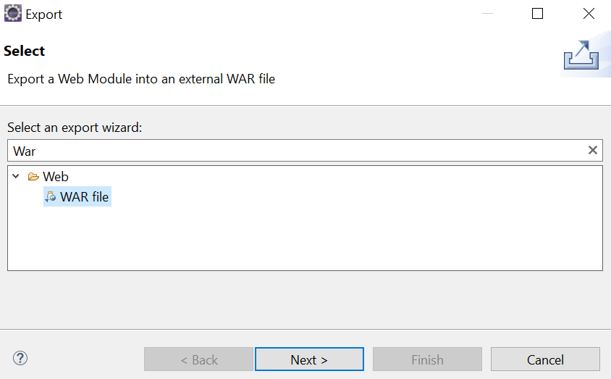

* Click next
* Browse your location where you are stored war file
* Click finish button

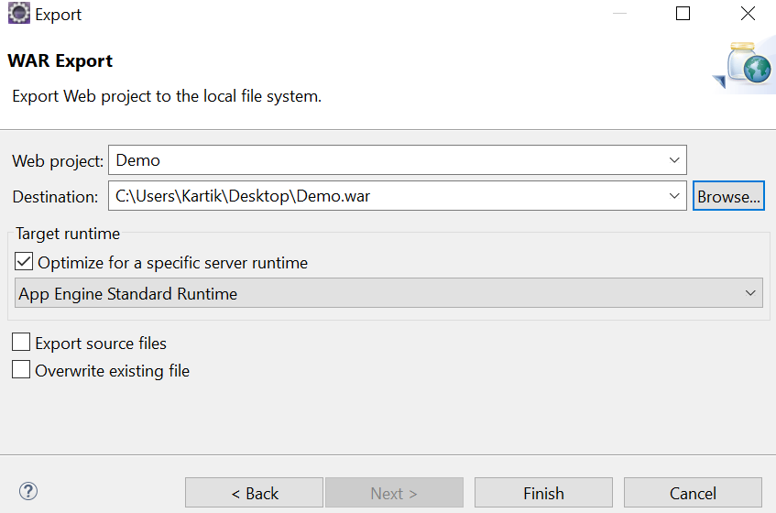

* Open Notedpad and write code

runtime: java

env: flex

handlers:

- url: /.*

script: this field is required, but ignored

* Give name app.yaml and save
* Now Click on google cloud platform icon in eclipse

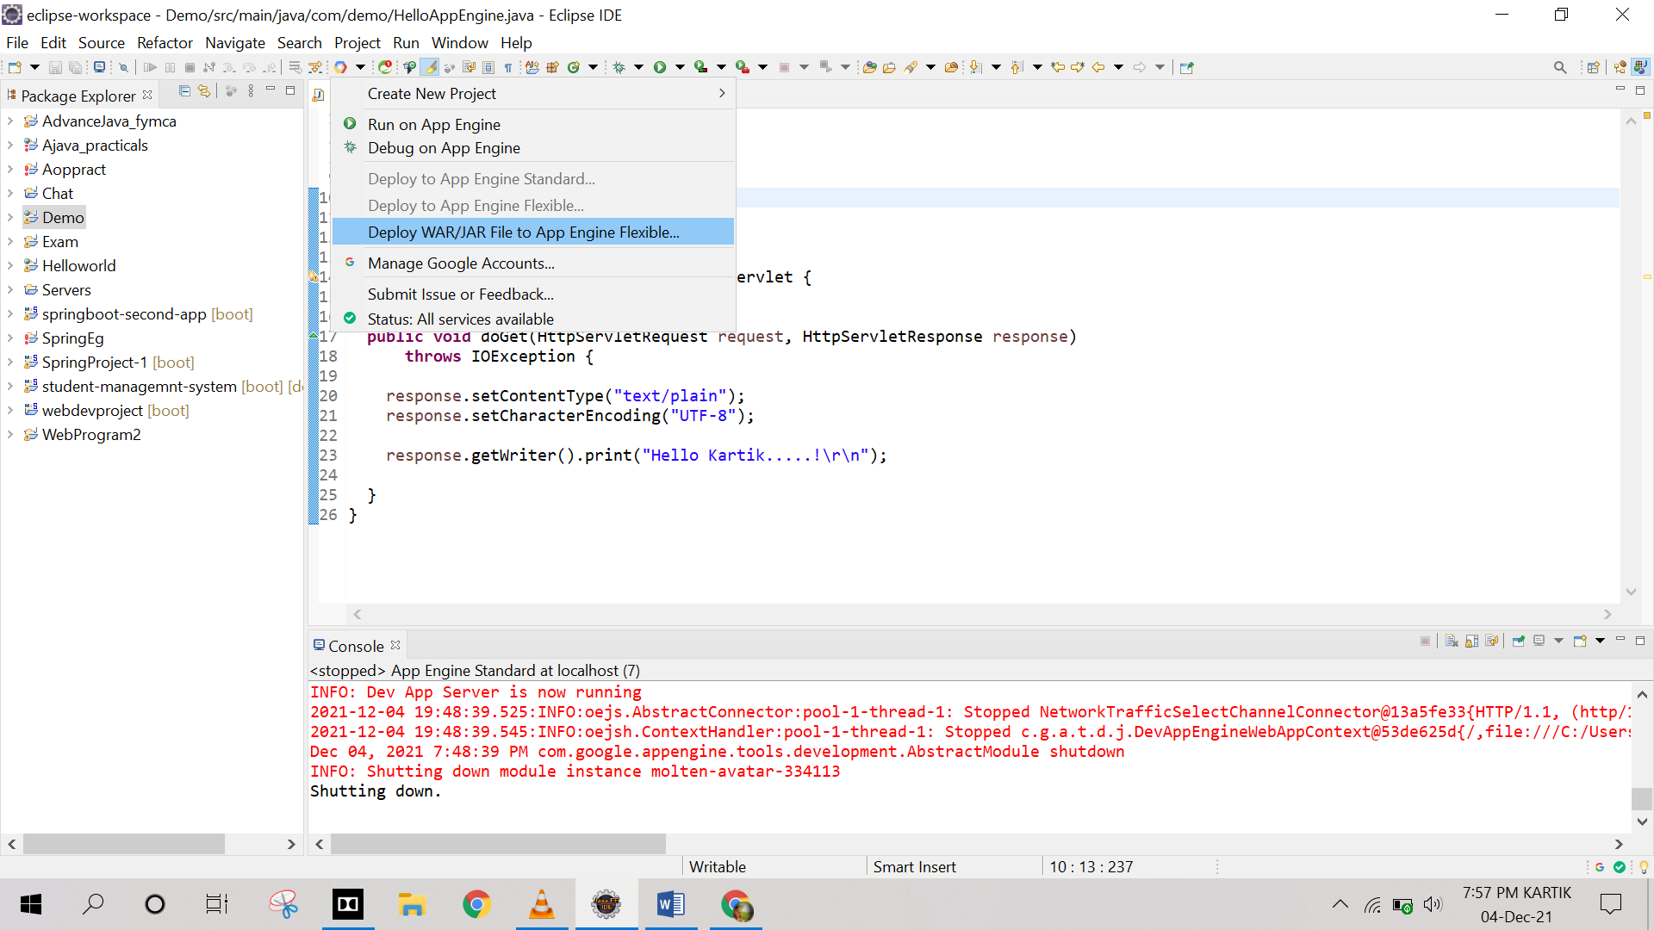

* Click on Deploy War/Jar File to App Engine Flexible
* Select your project
* Browse your War and yamal file
* Click on Deploy button

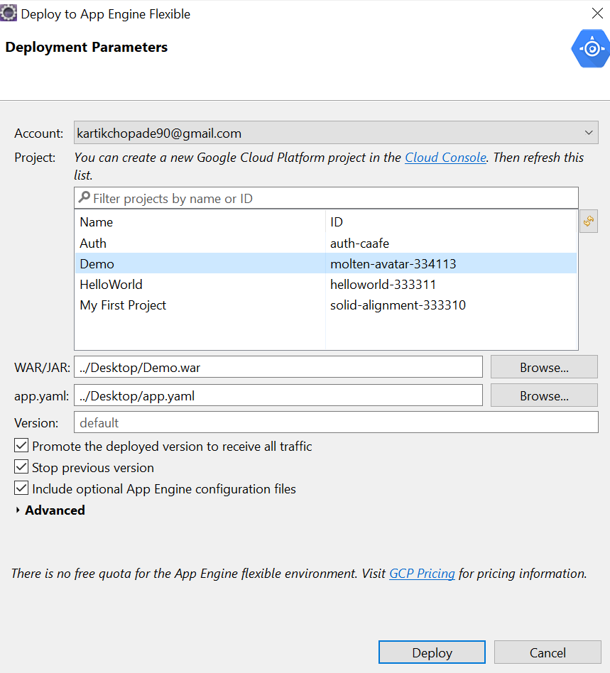

* Now Click on Deploy to App Engine Standard

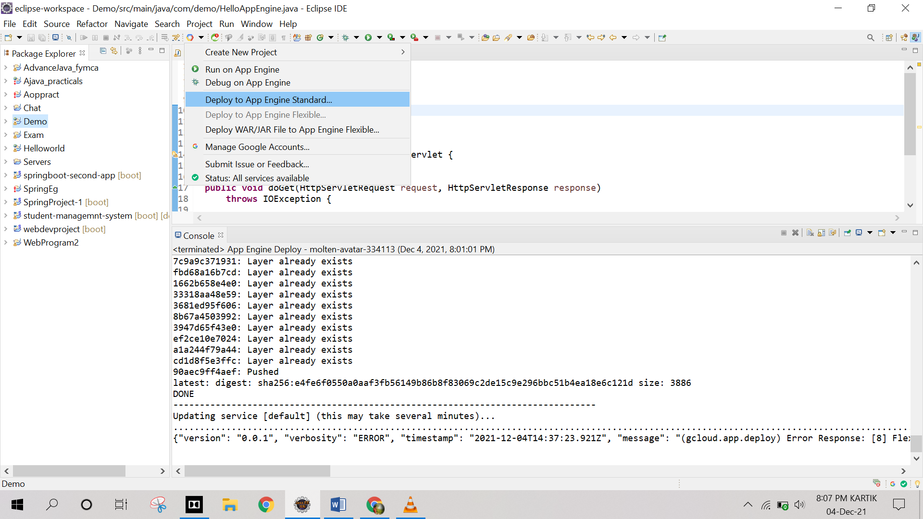

* Select your project name
* Click on Deploy button

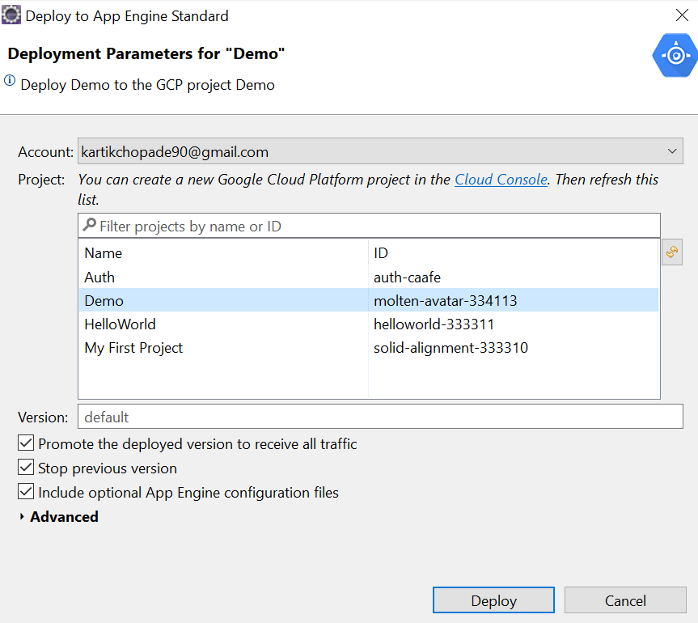

**Output:**

